Start of the Project
Press conference after the Kick-Off Meeting, 22 March 2015, Bishkek

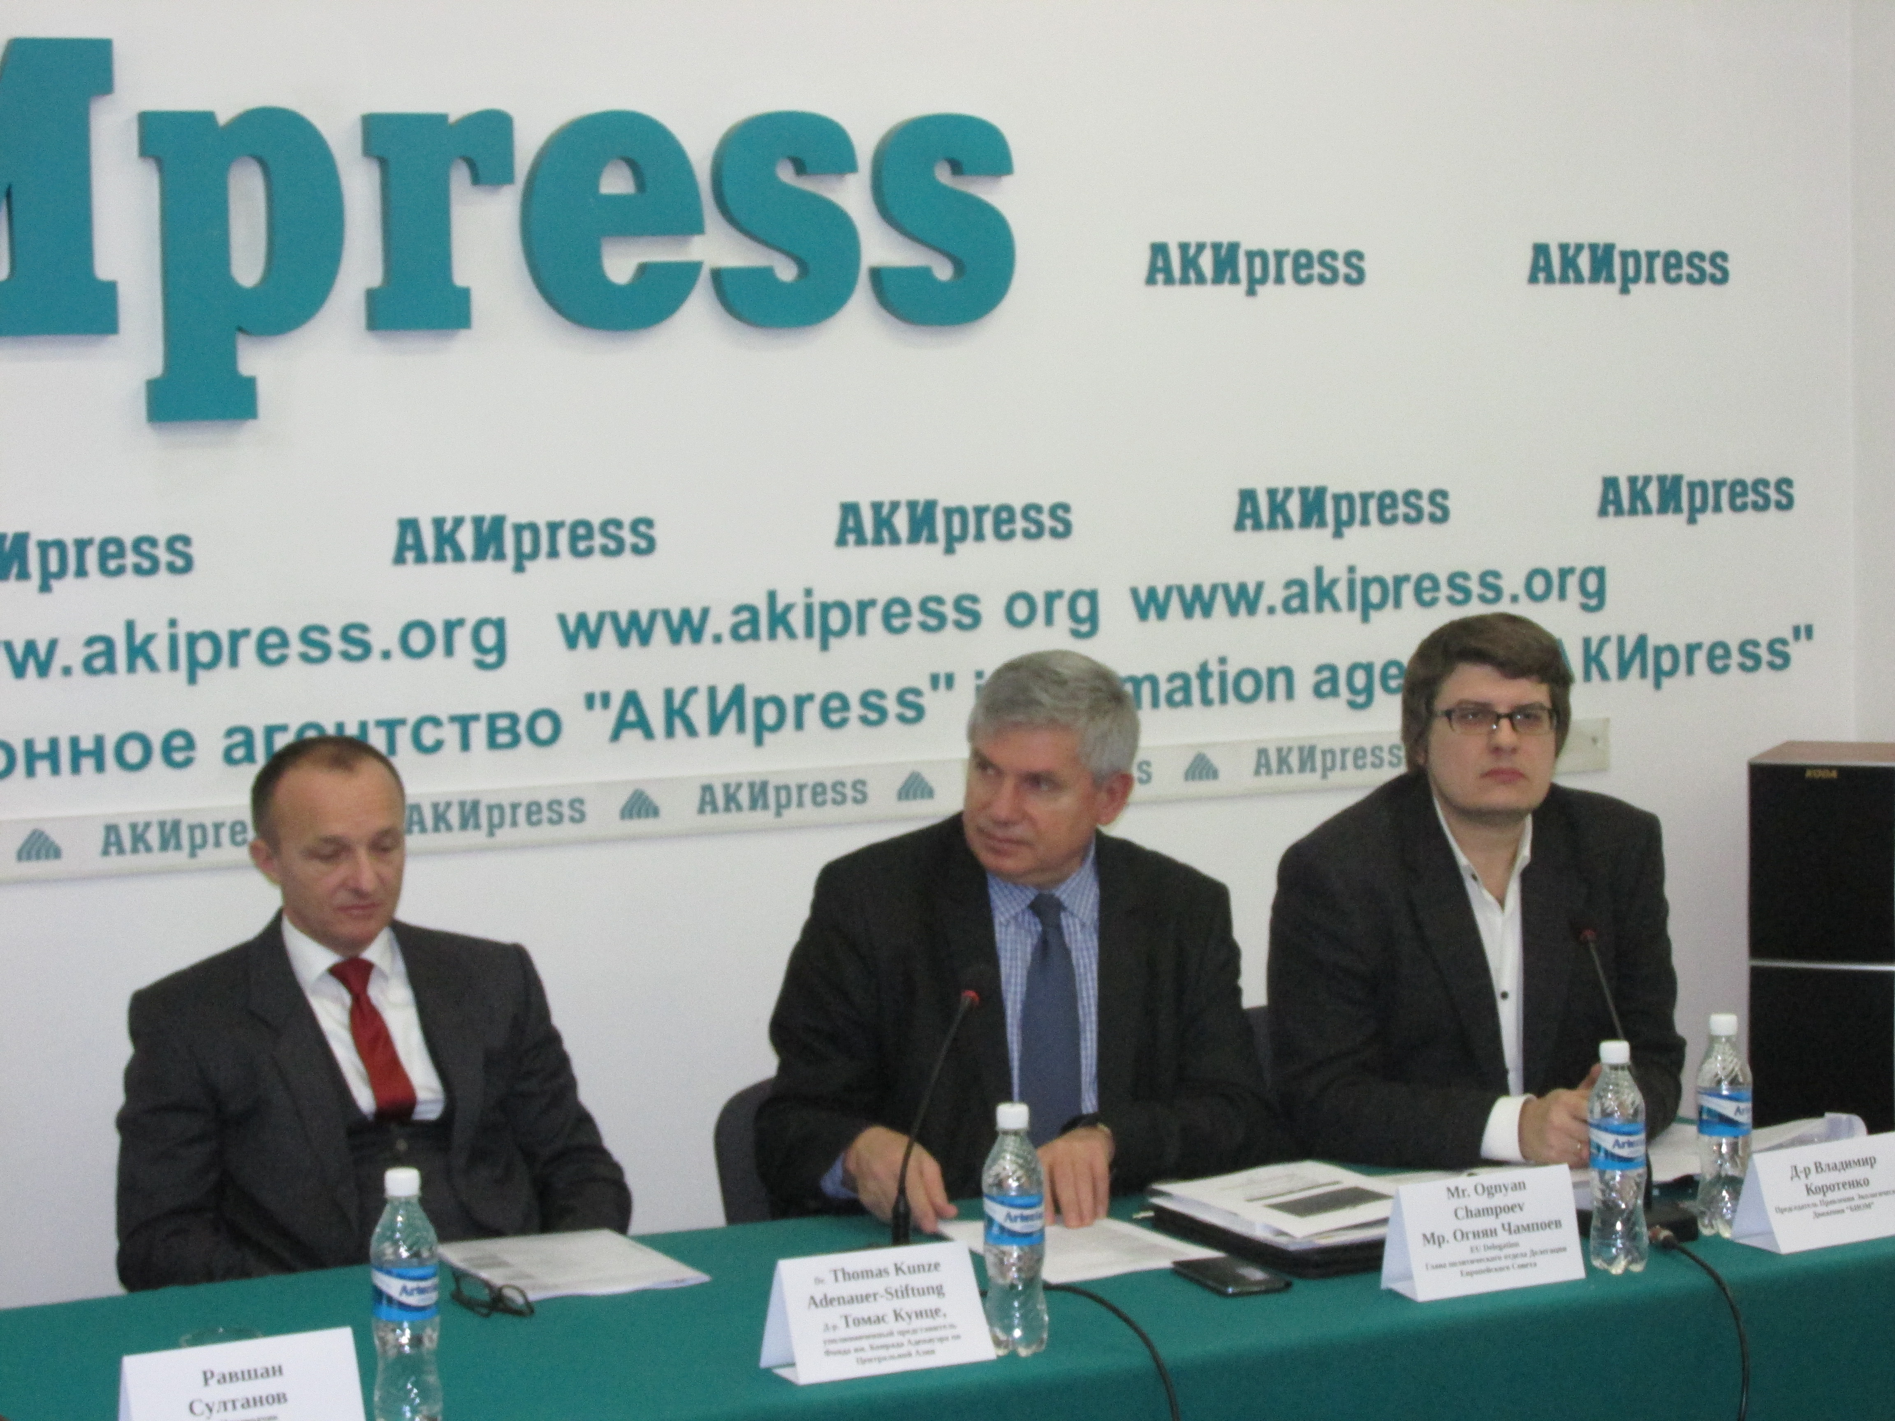

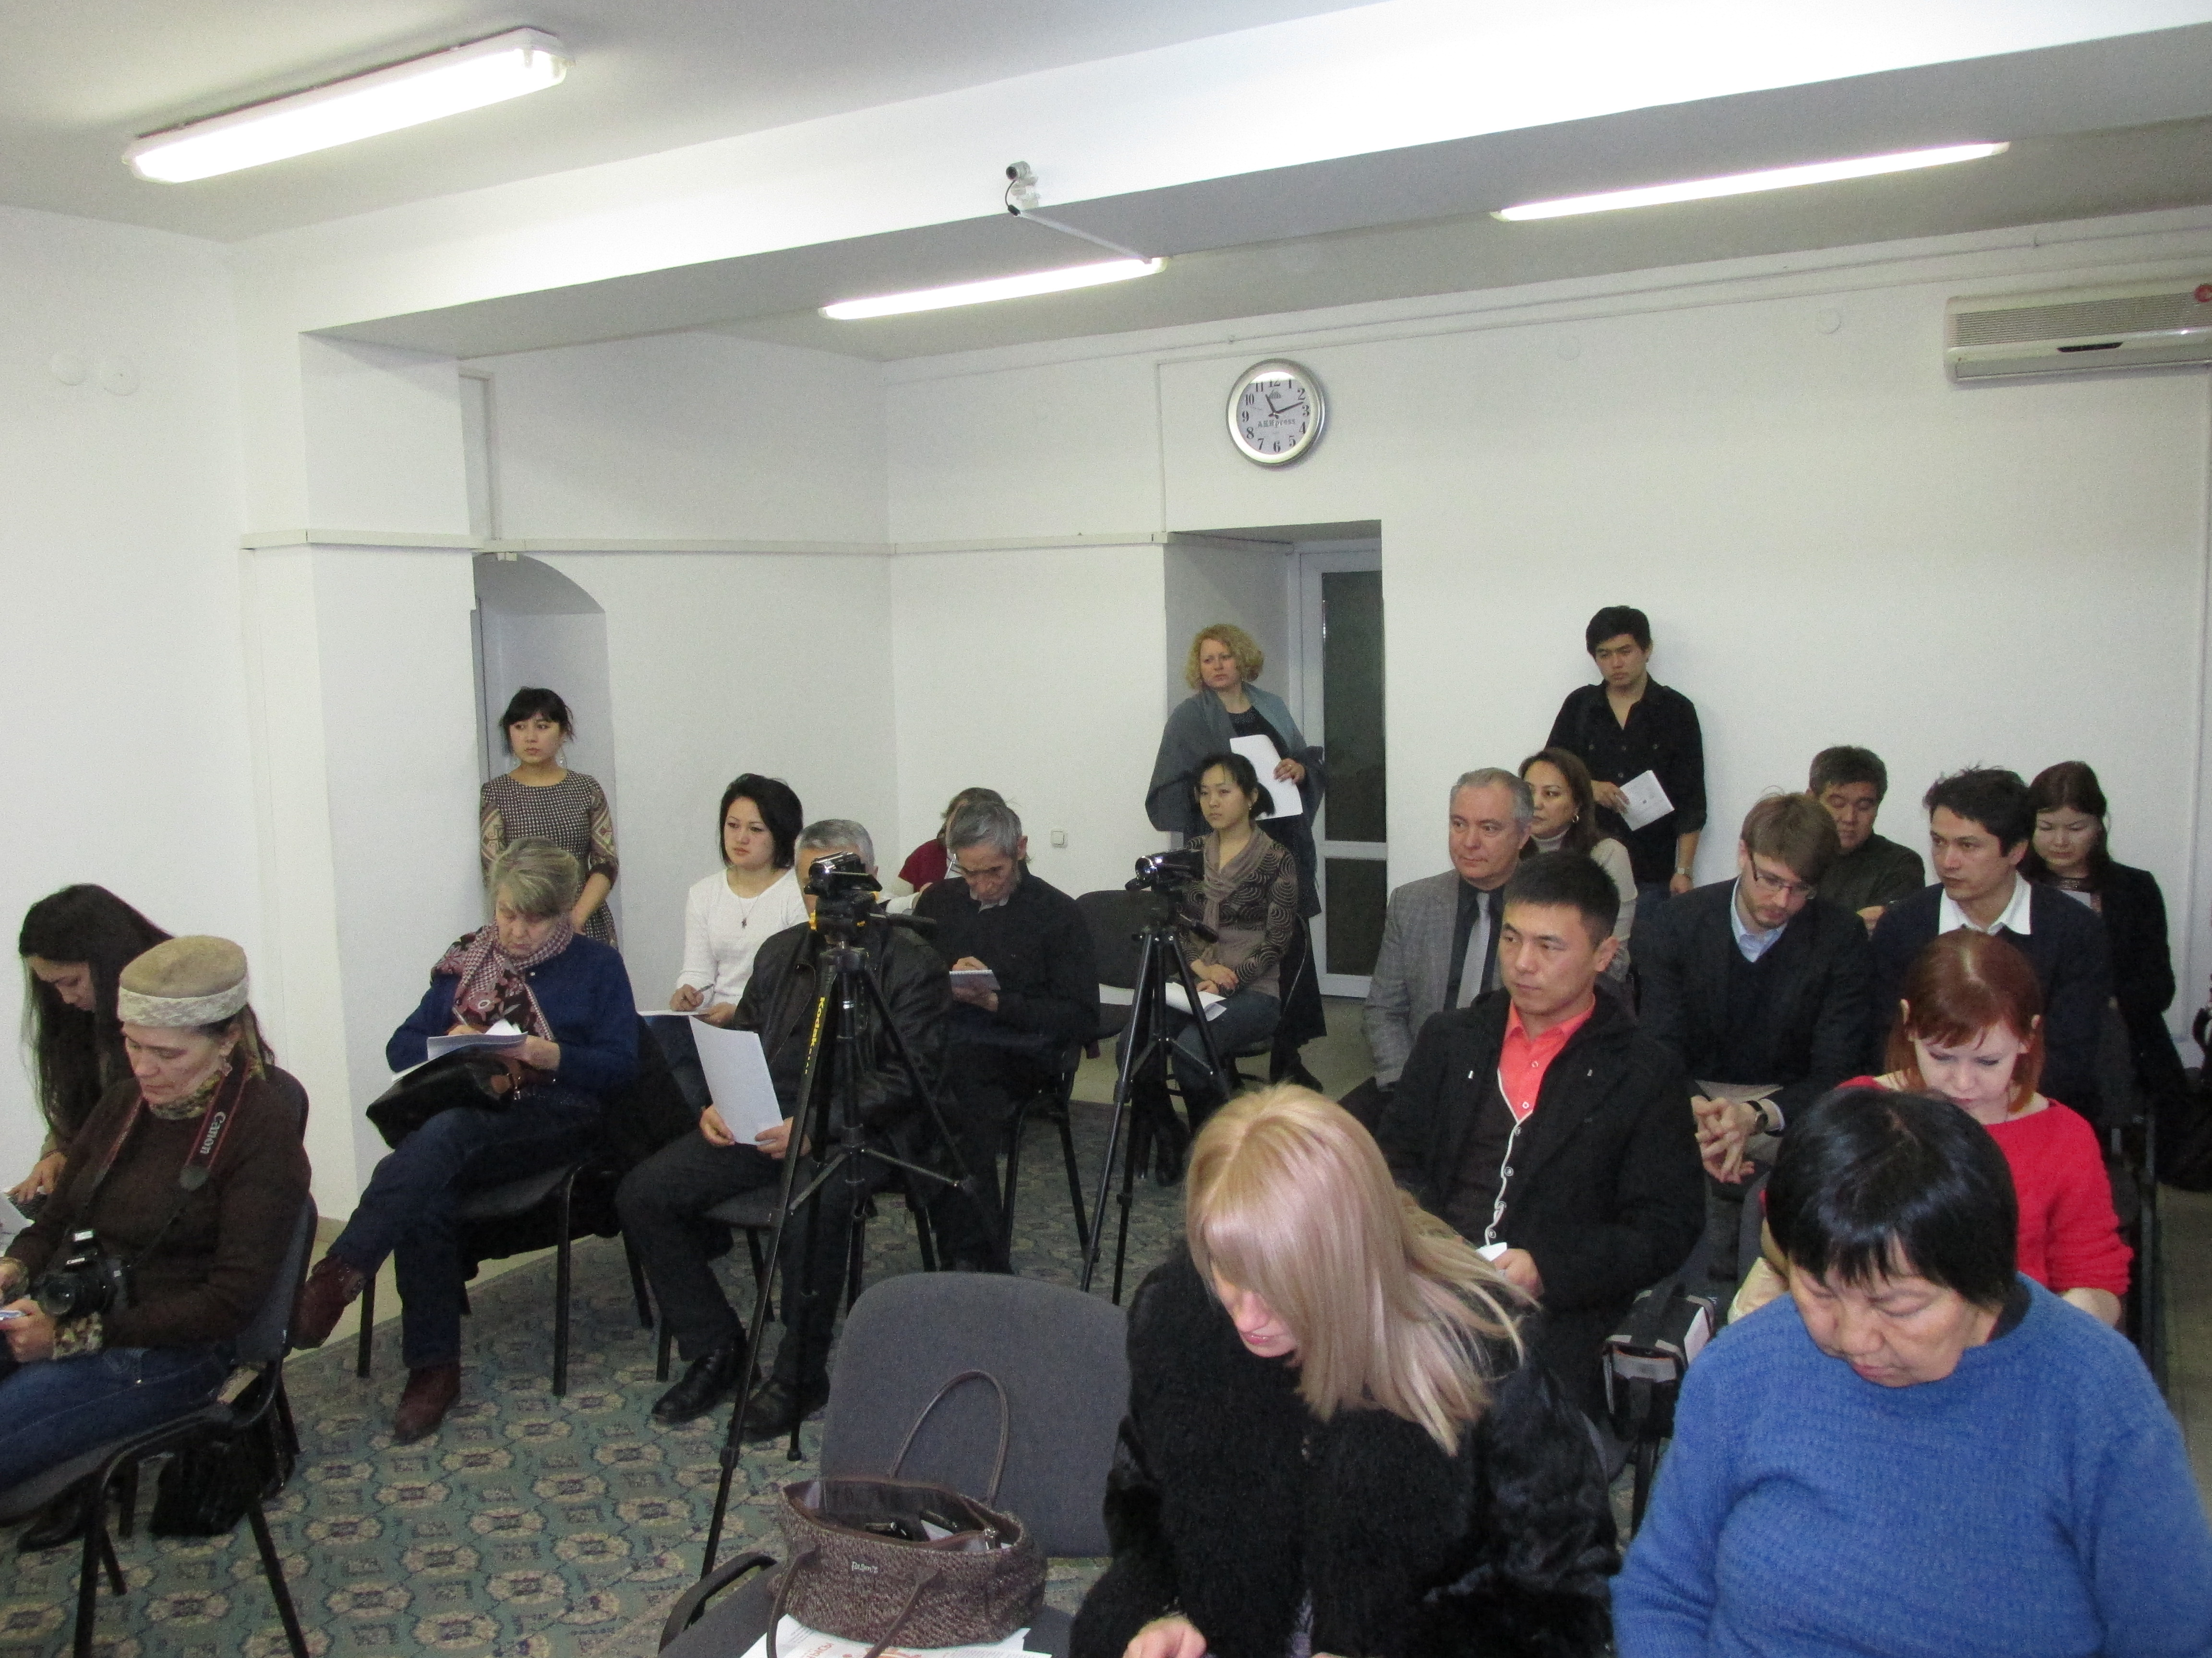
Seminar for members of the Public Council of the Ministry of Education and Science of the Kyrgyz Republic "Practices of public monitoring and evaluation of educational reforms", 27-30.06.2015, Bishkek

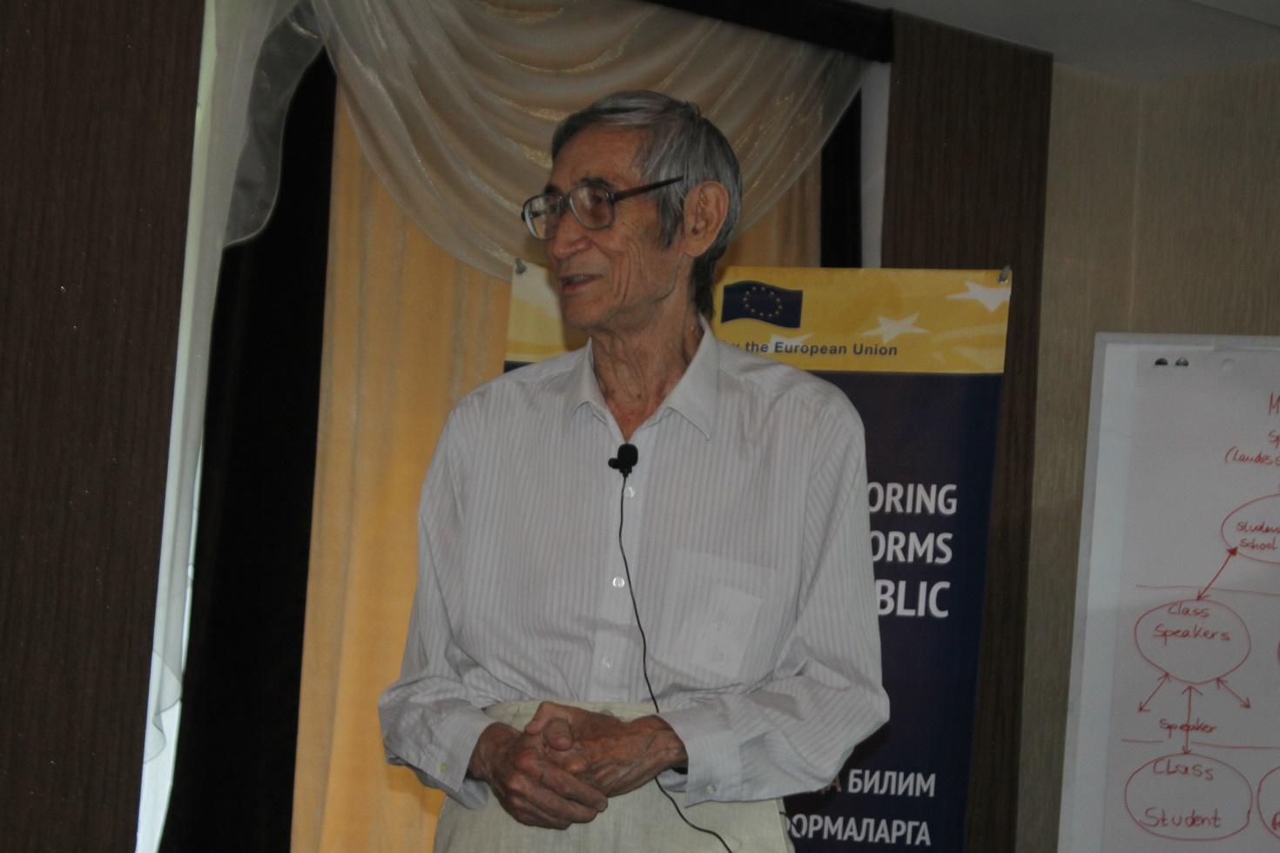

Speech of prof. E. Dj. Shukurov

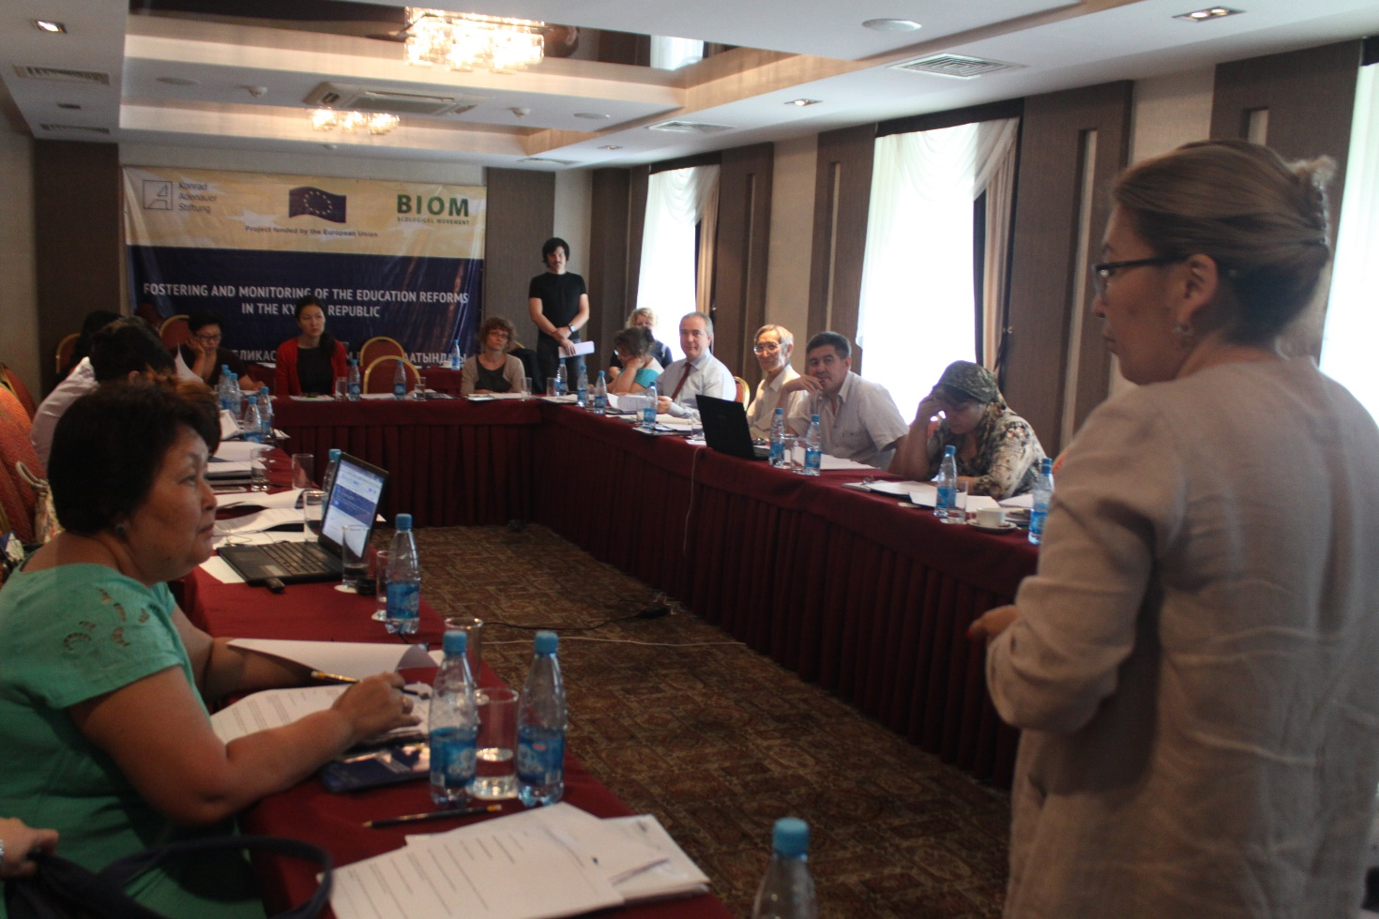

Speech of Dr. A. Niyazova (Head of the Chair of Civil Law and Process of the KRSU)

Round table on the content and quality of education,
10.07.2015, Bishkek

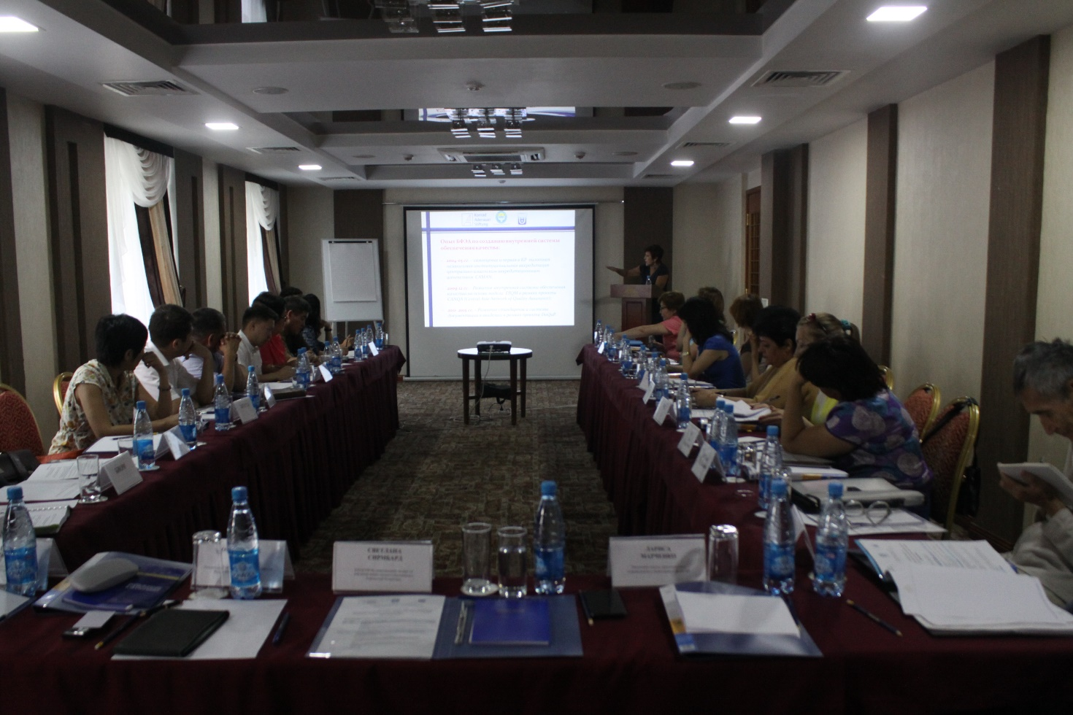

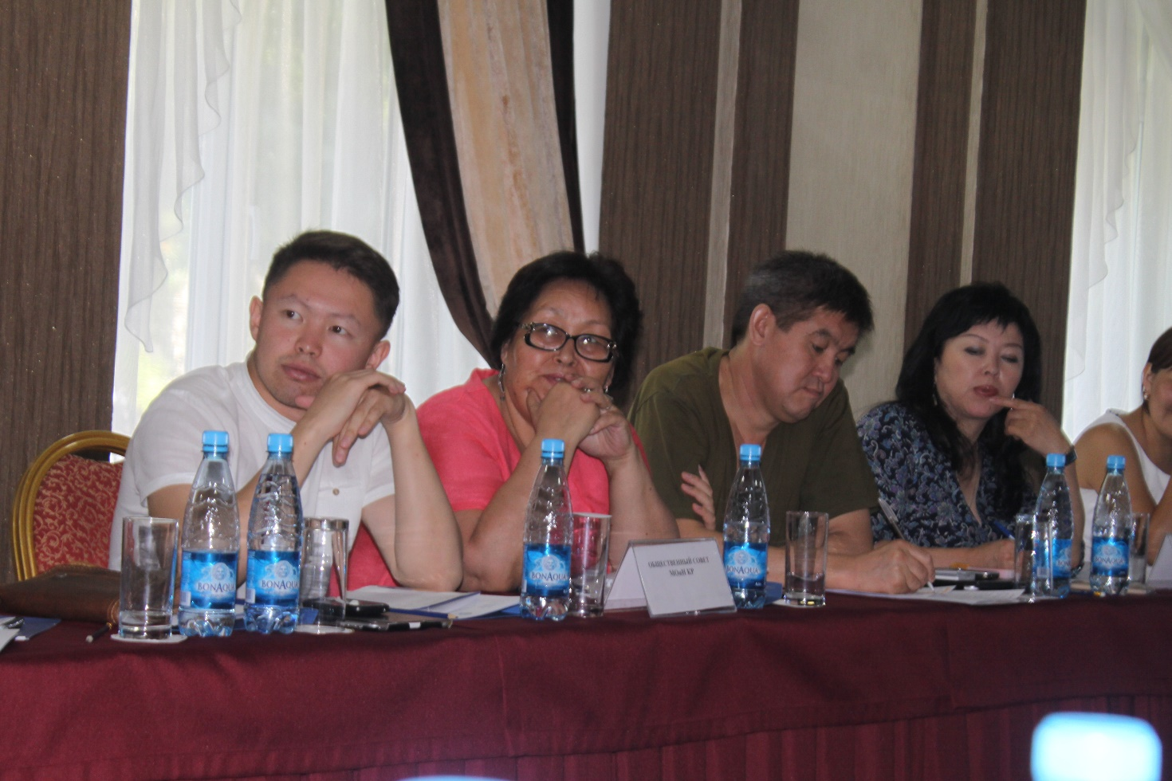

Working meeting on the development of the strategic and operational plan of the Public Council of the Ministry of Education and Science of the Kyrgyz Republic,
05-08.08.2015, Issyk-Kul

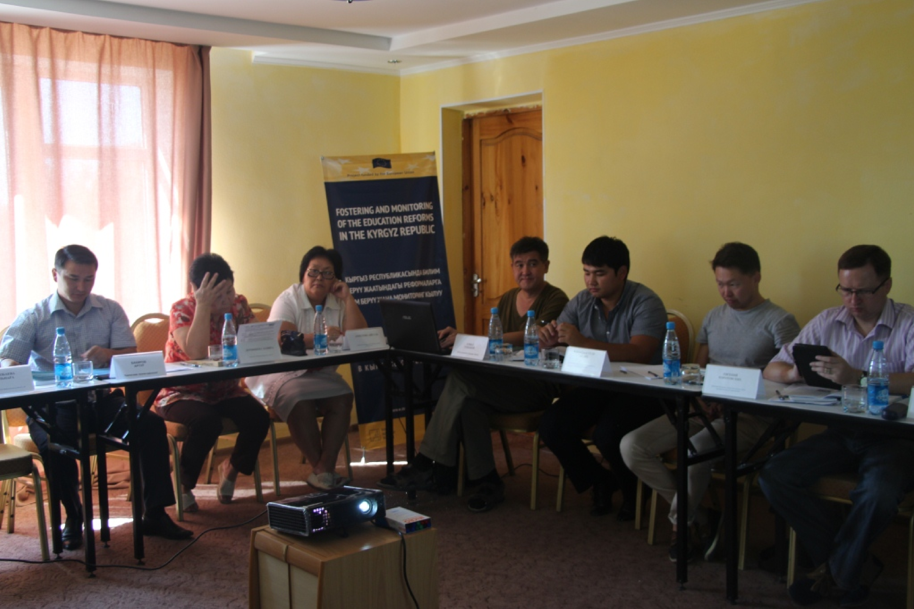

Members of the Public Council of the Ministry of Education and Science of the Kyrgyz Republic

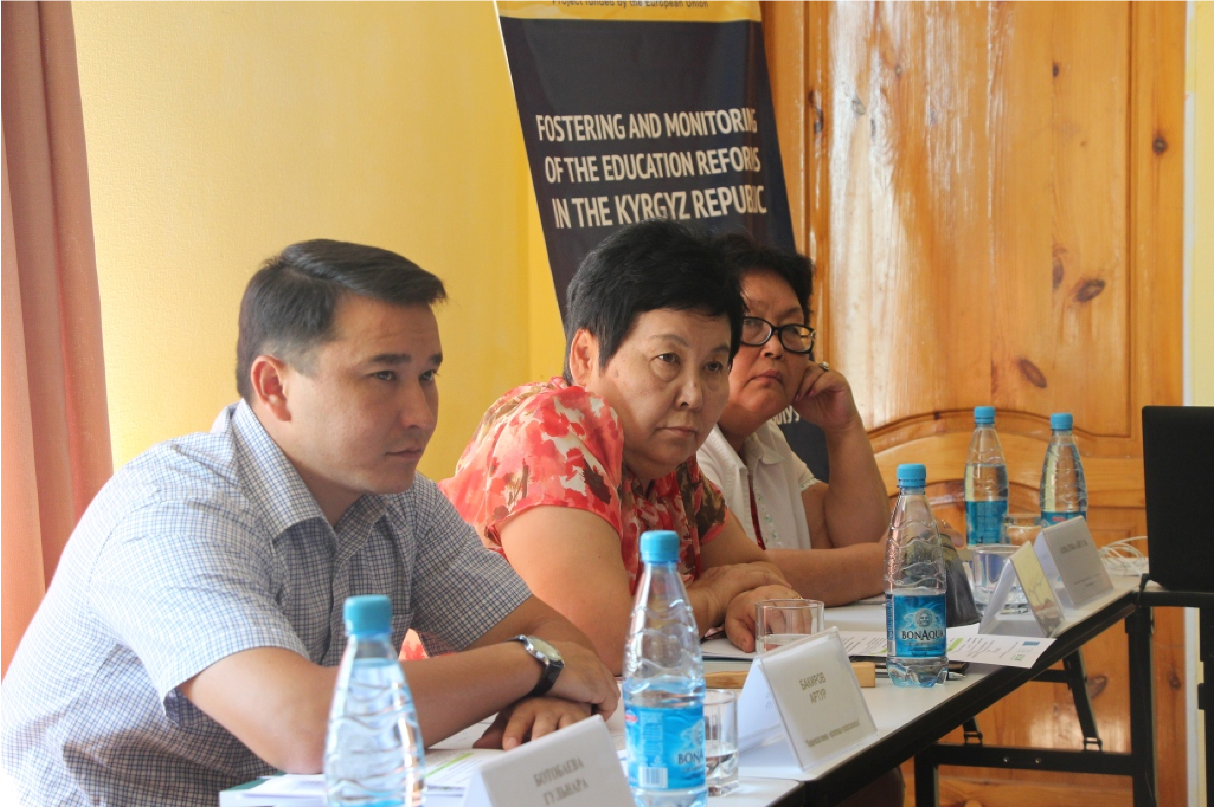

Meeting of the working group of analytical experts on education management, 11.09.2015, Bishkek

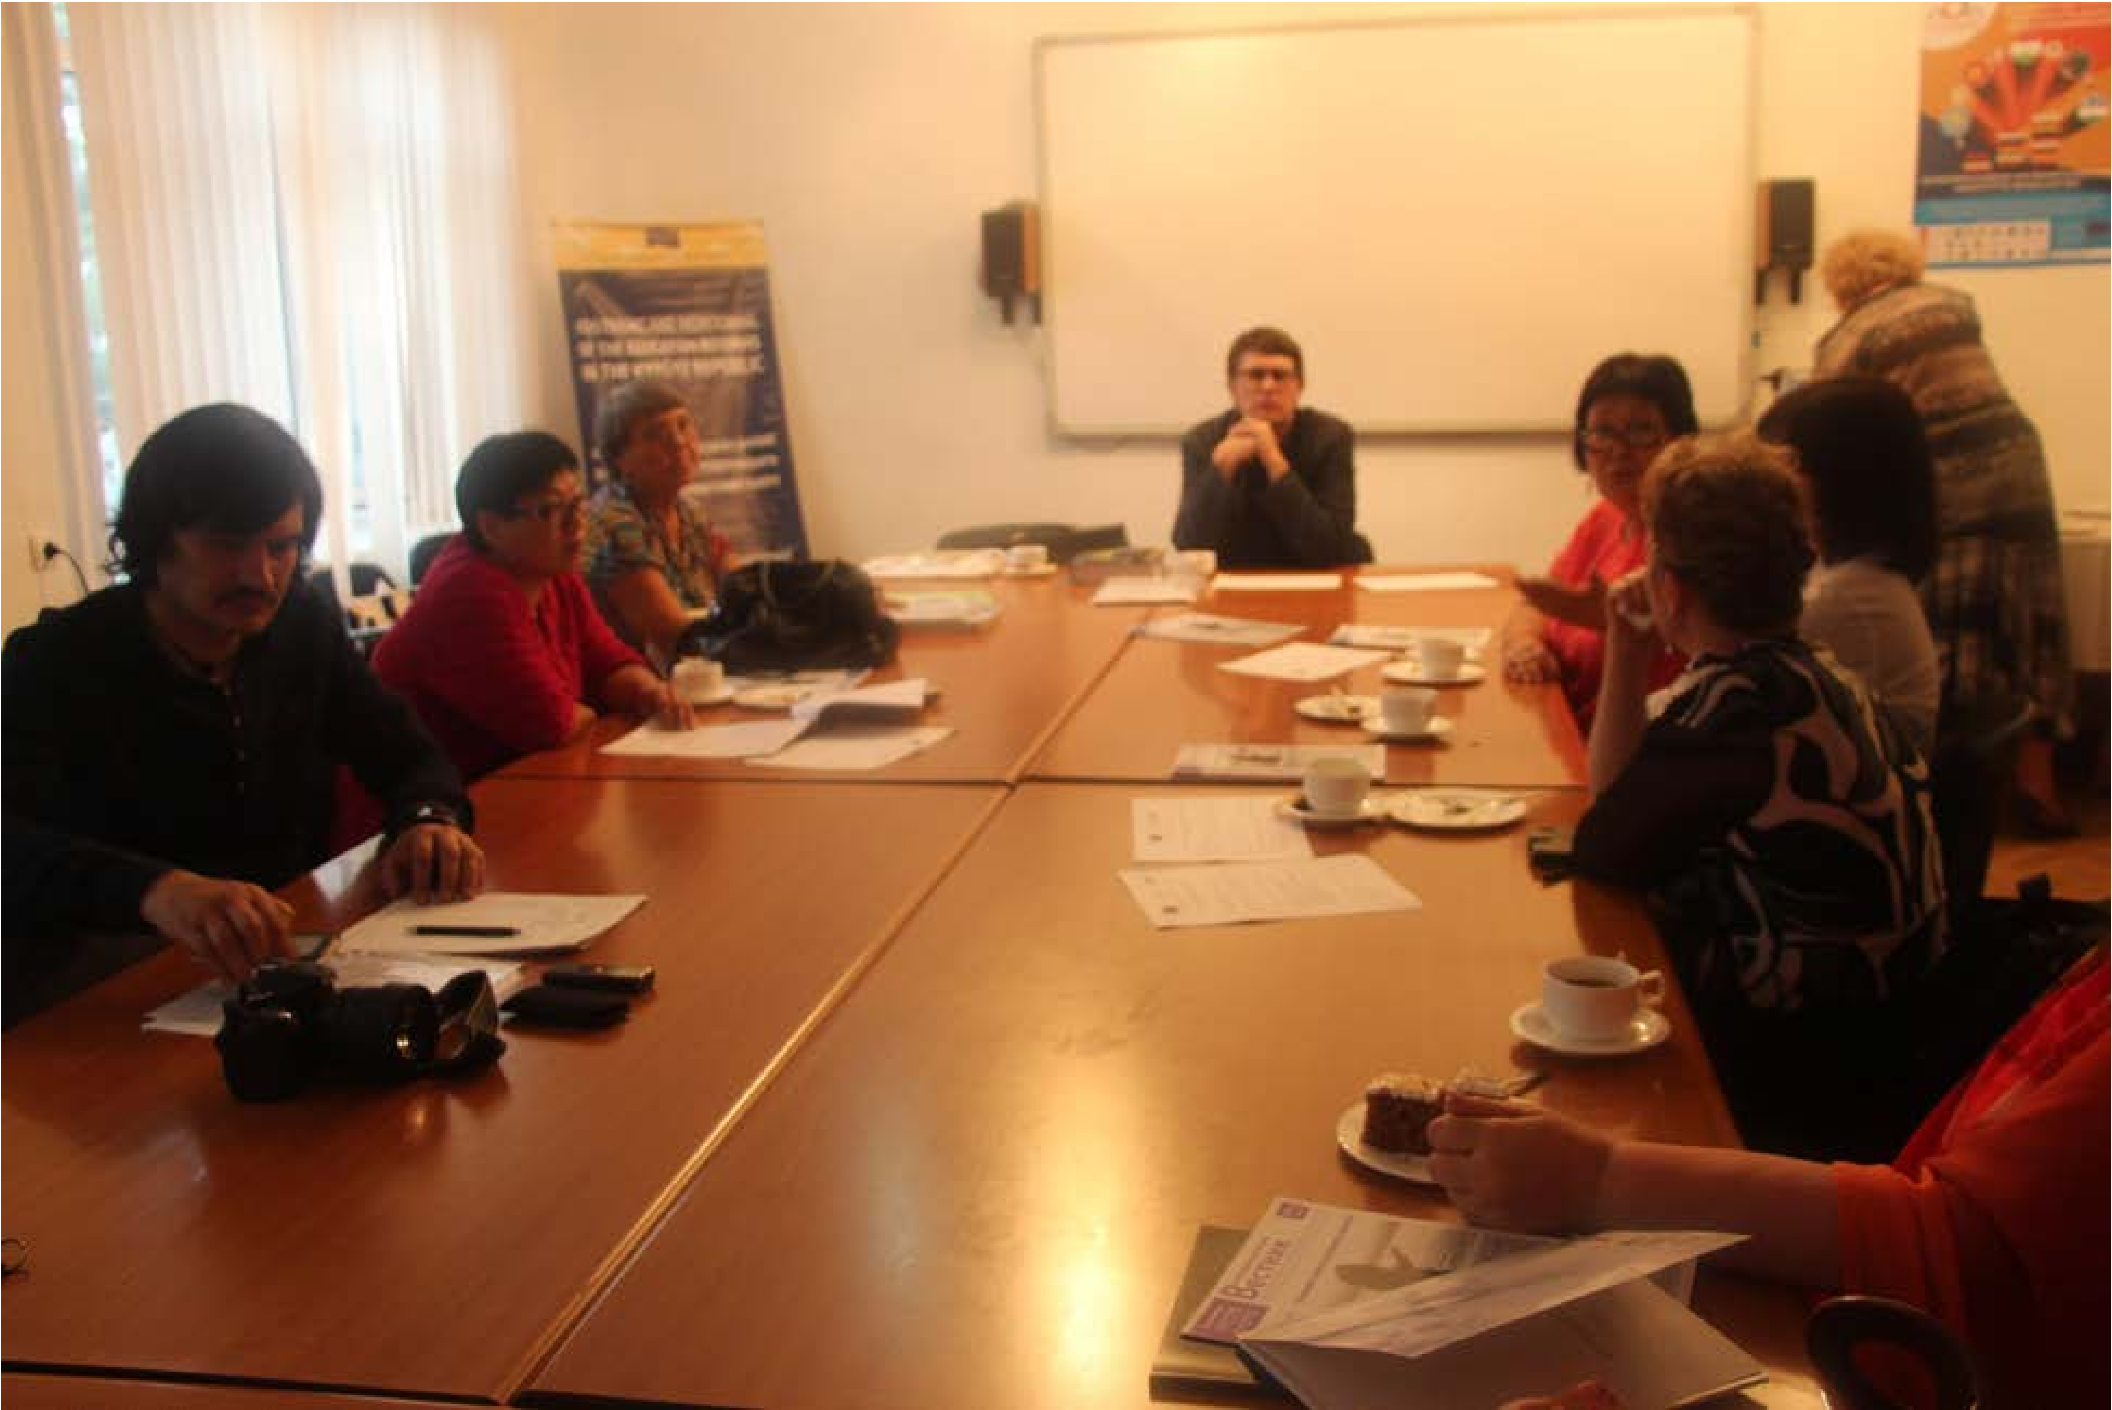

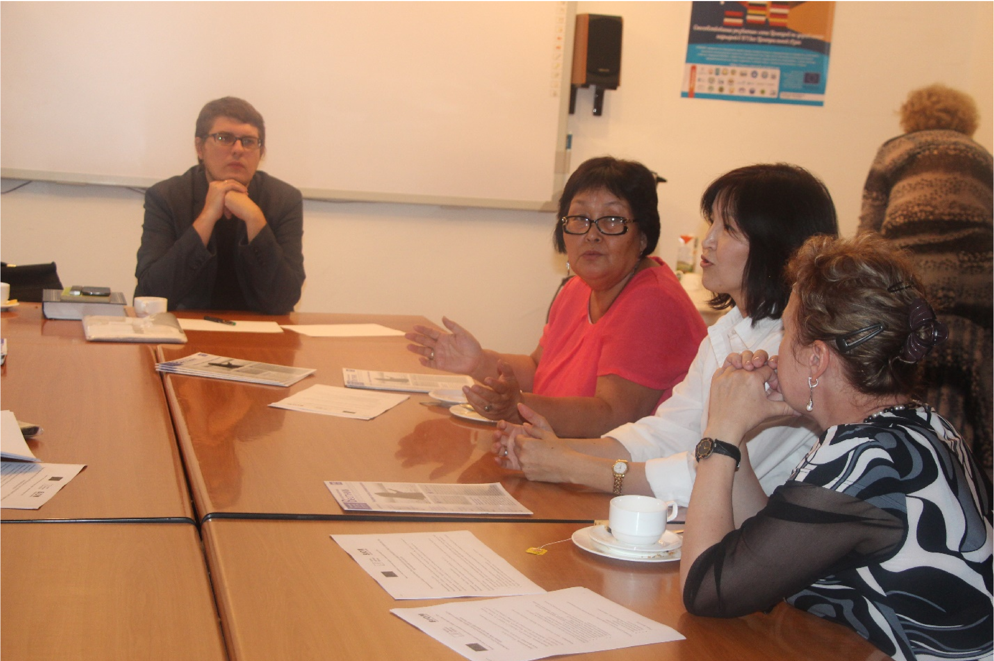

Round table in the Ministry of Education and Science of the Kyrgyz Republic on the monitoring of educational reforms, 25.09.2015, Bishkek

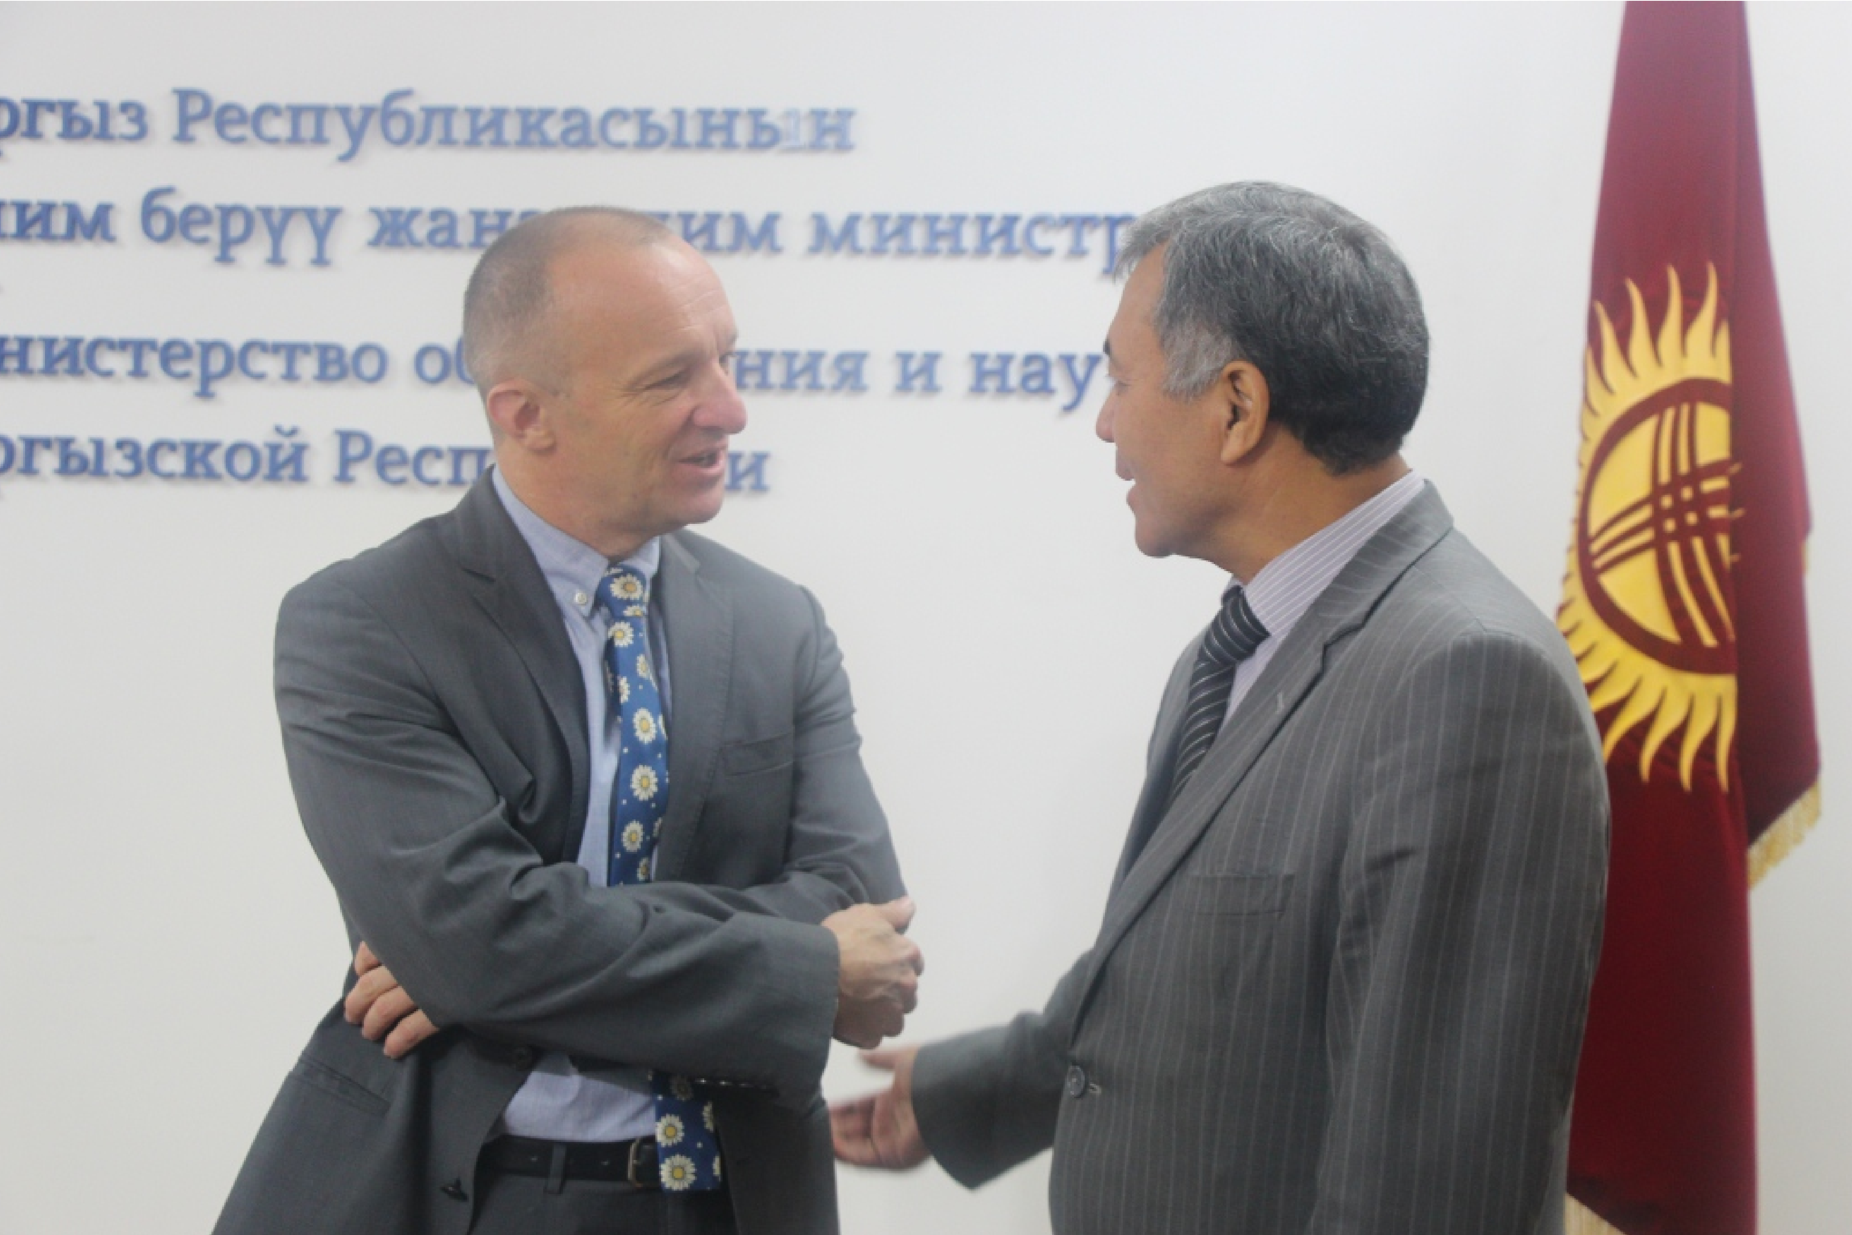

Dr. Thomas Kunze (Authorized representative of the Konrad Adenauer Foundation in Central Asia) and Dr. Tuuganbay Konurbayev (Pro-rector for Academic Affairs of KSU named after I.Arabayev)

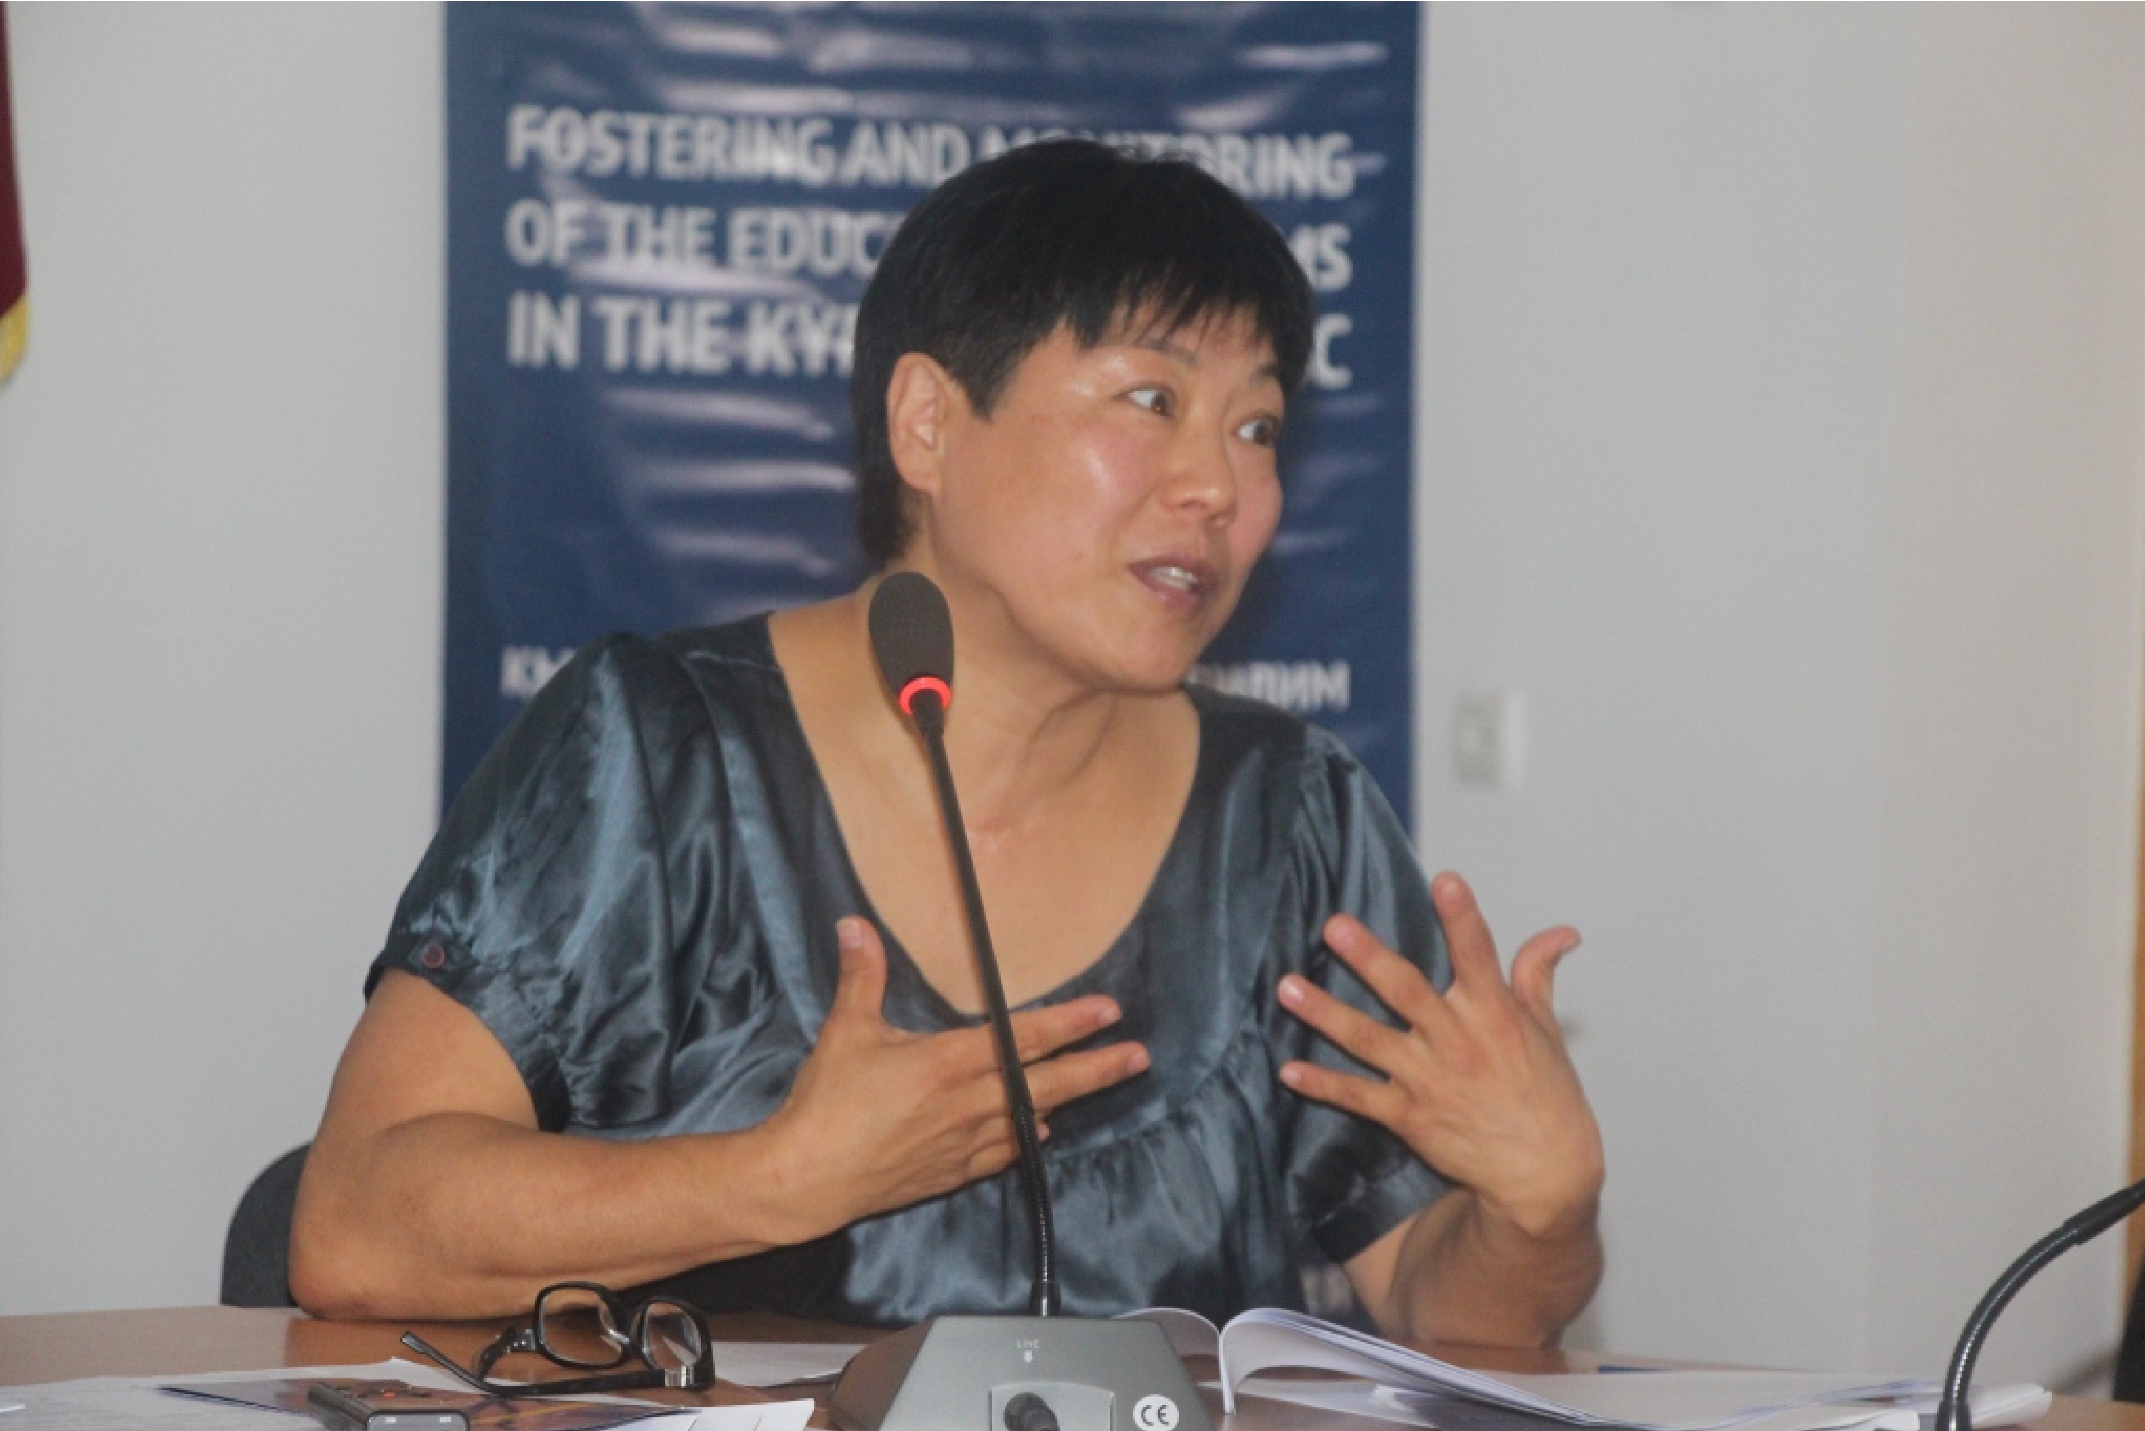

Speech of Ch. Omurkulova (Deputy Chairman of the Public Council of the Ministry of Education and Science of the Kyrgyz Republic)

Round table on the quality of education. Discussion of the framework of the Quality Council, 16.11.2015, Bishkek
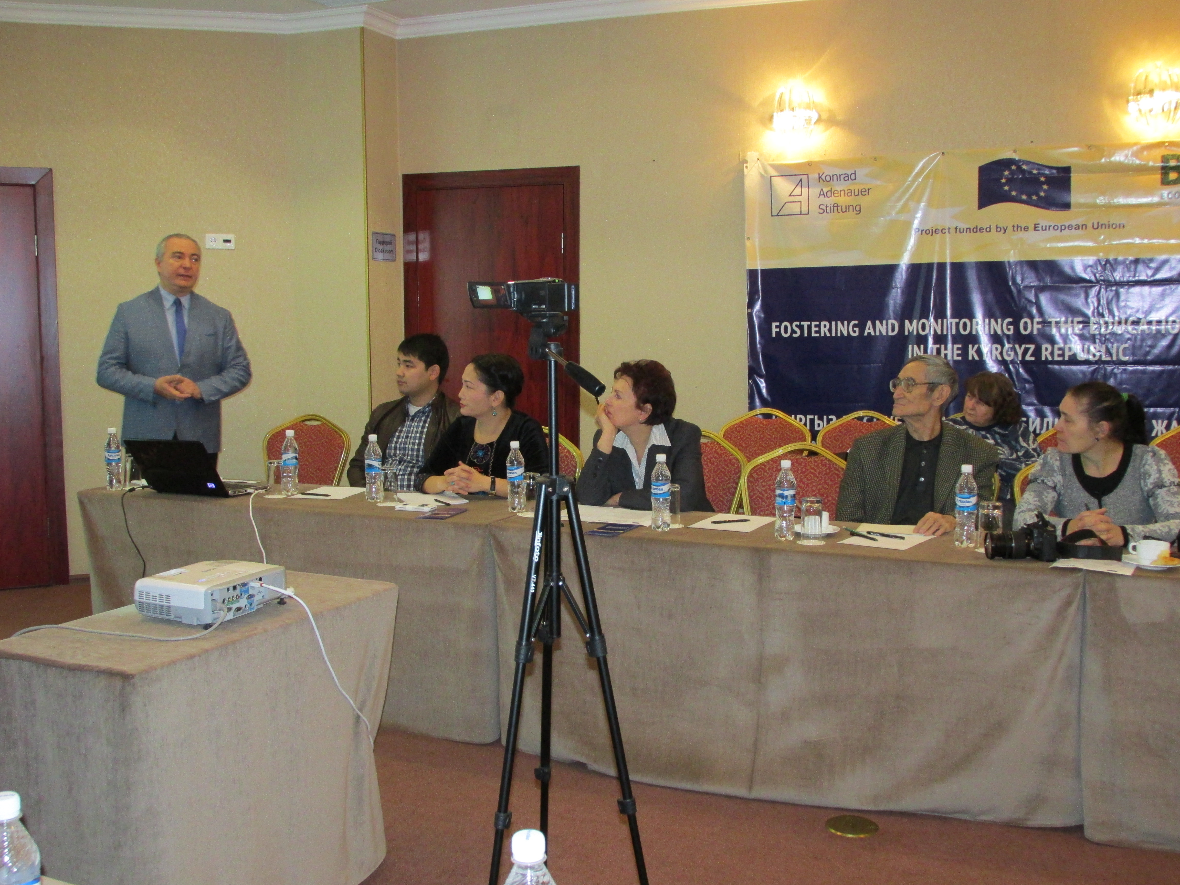

Speech of Prof. A. Zybkin (Project Training Coordinator)

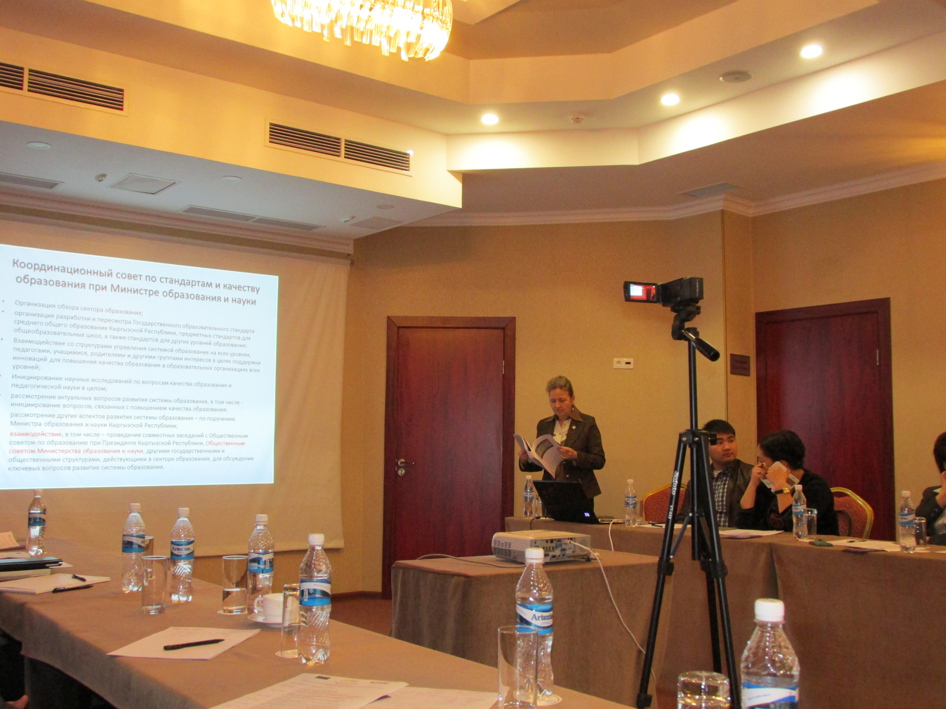
Speech of L. Marchenko (Advisor to the Minister of Education and Science of the Kyrgyz Republic)
Meeting of the Public Council of the Ministry of Education and Science of the Kyrgyz Republic on finalizing the strategic plan, 10.12.2015, Bishkek

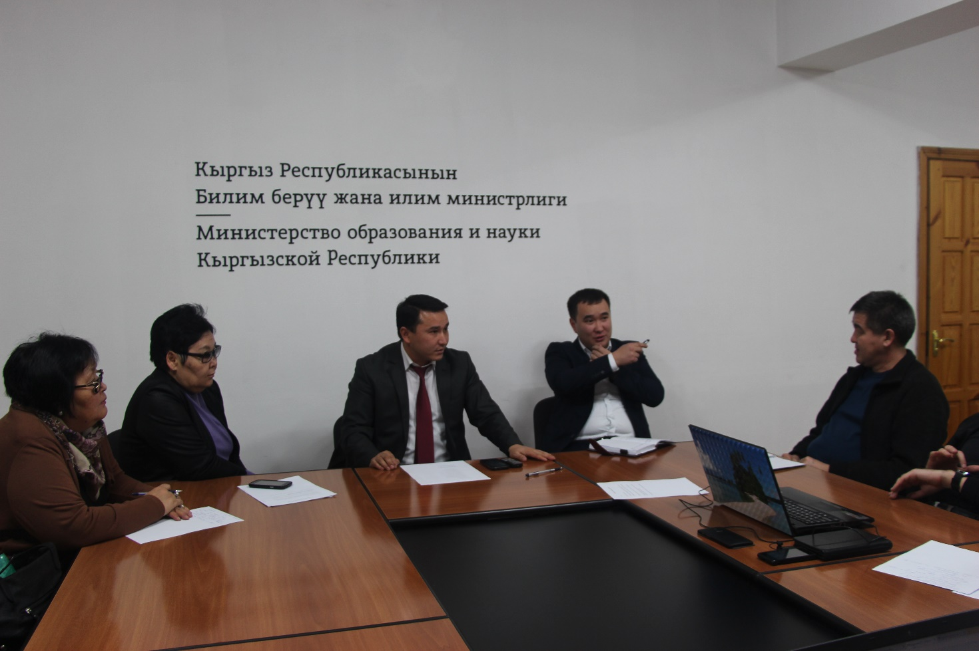

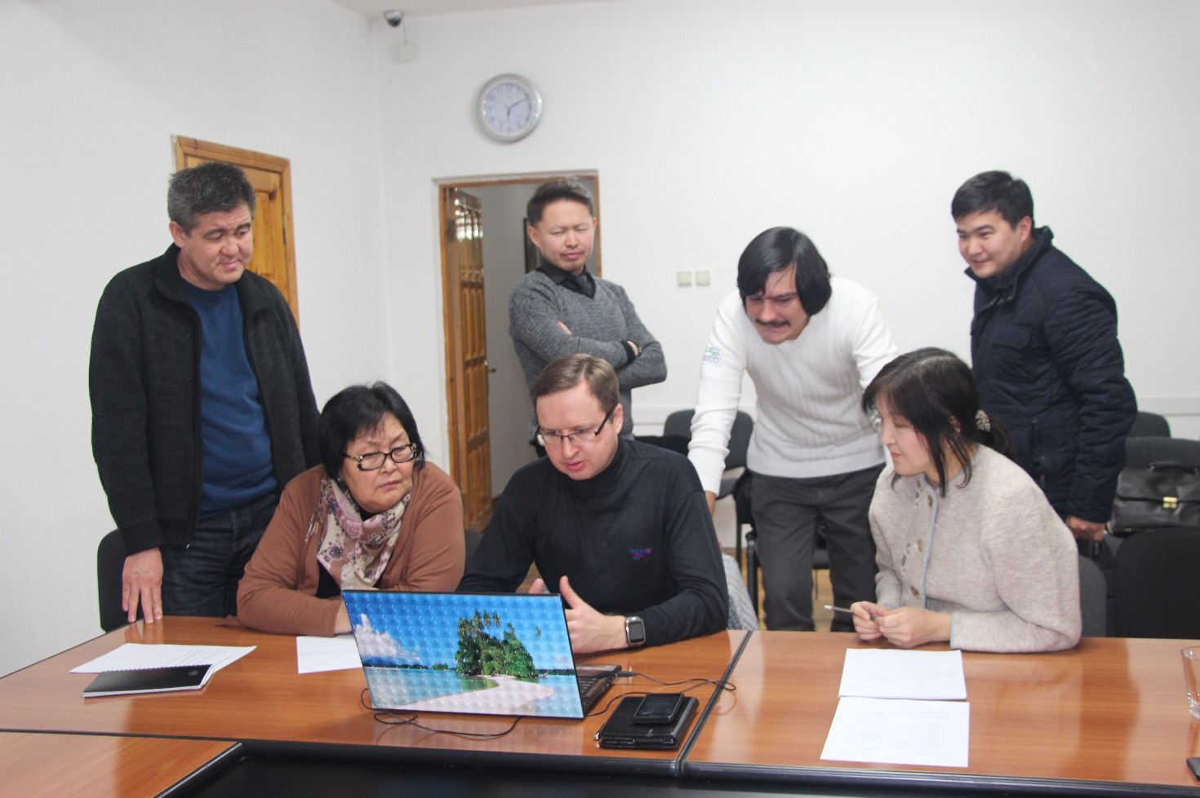

Workshop on Quality Assurance and Assessment of Education, 12.12.2015, Bishkek

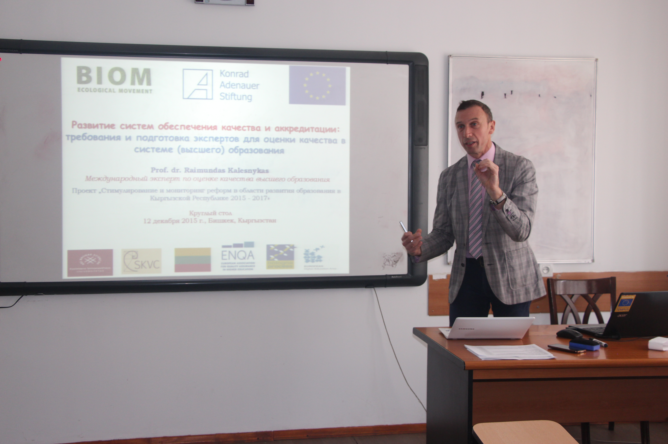

Speech of Dr. Raimundas Kalesnykas (International expert, Head of the analytical group on the quality of education)

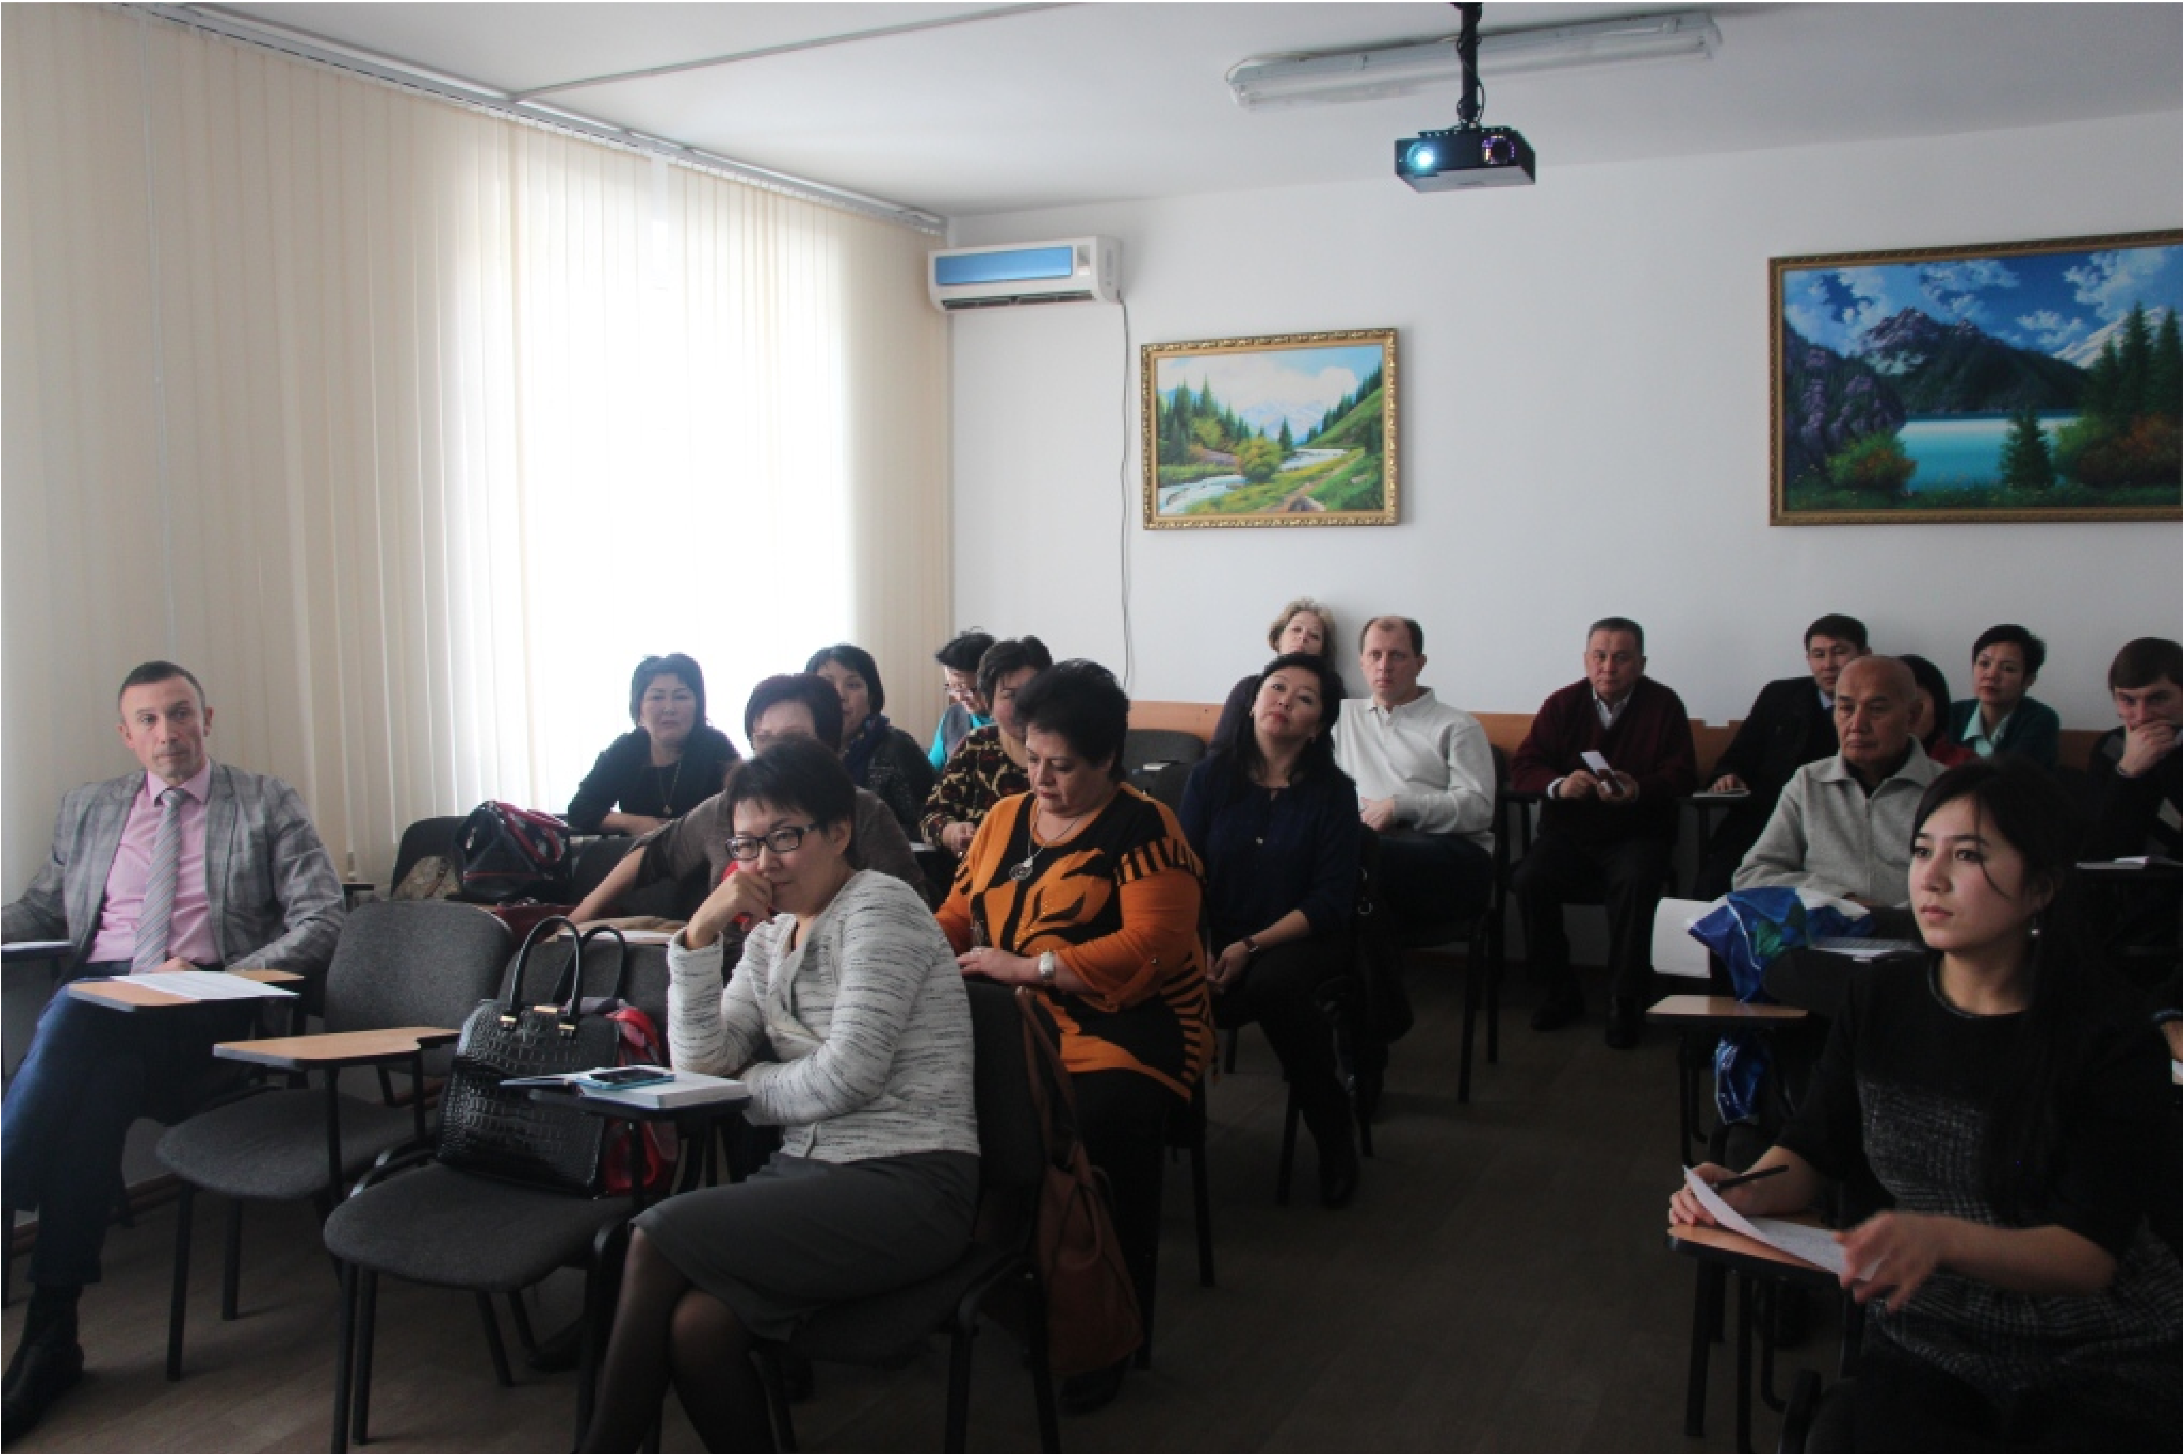

Workshop on Education for Sustainable Development,
14.12.2015, Bishkek

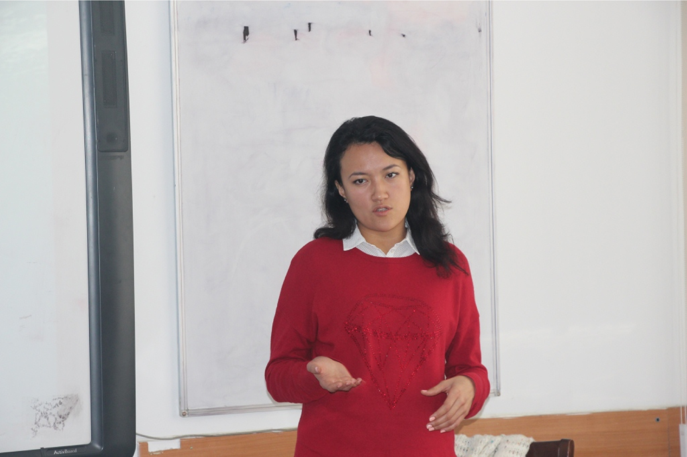

Speech of E. Dzhumakadyrova (Senior Program Assistant of the Department
for Economy and Environmental Protection of the OSCE Center in Bishkek)

Presentation of analytical work of the working group of experts

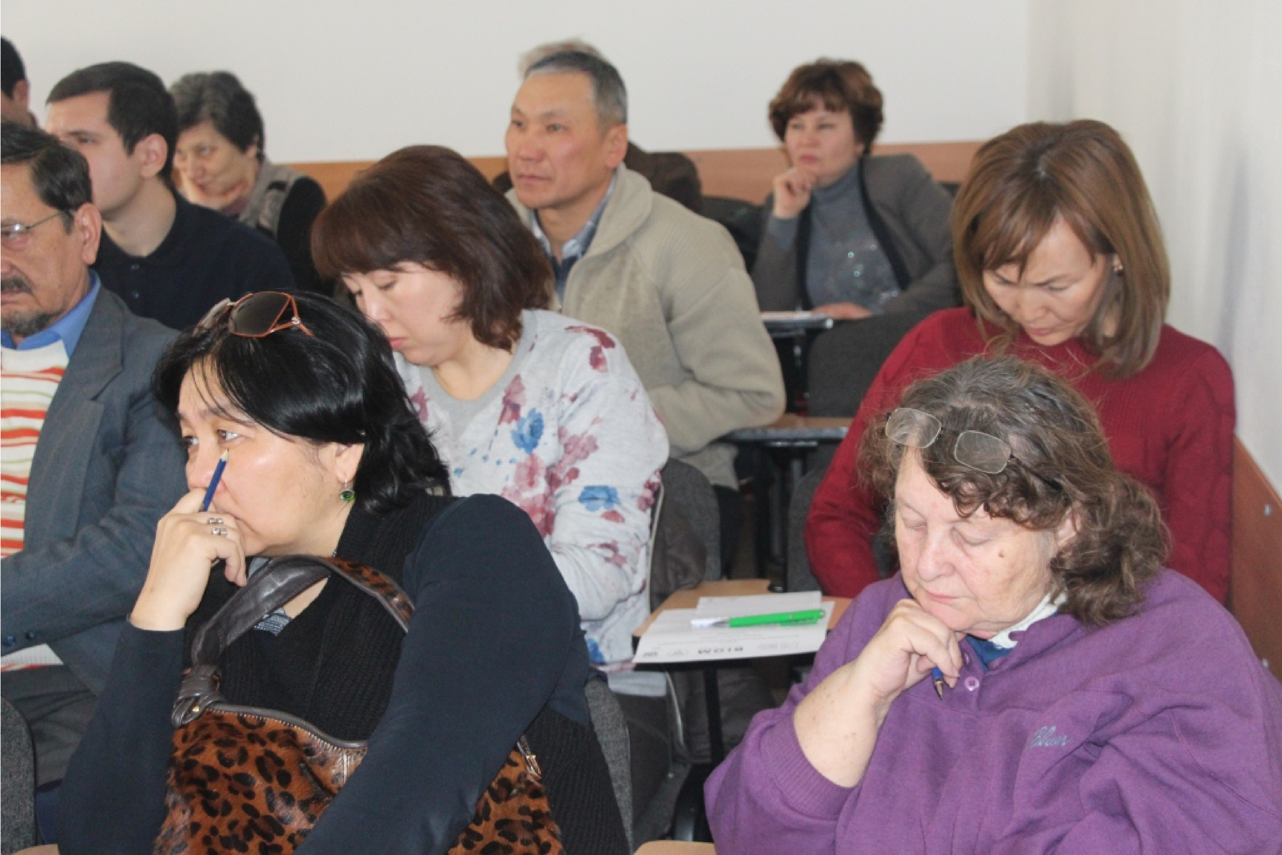

Workshop on gender dimension of education, 17.12.2015, Bishkek,

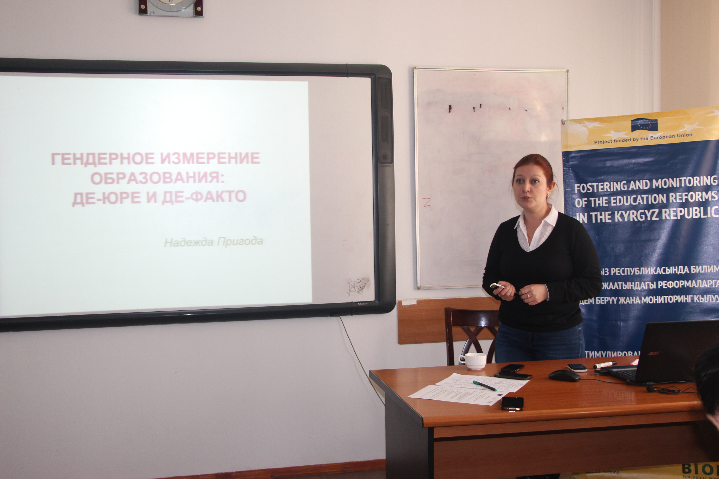

Speech of Dr. N. Prigoda (Associate Professor of Kyrgyz-Russian Slavic University)

Presentation of analytical work of the working group of experts

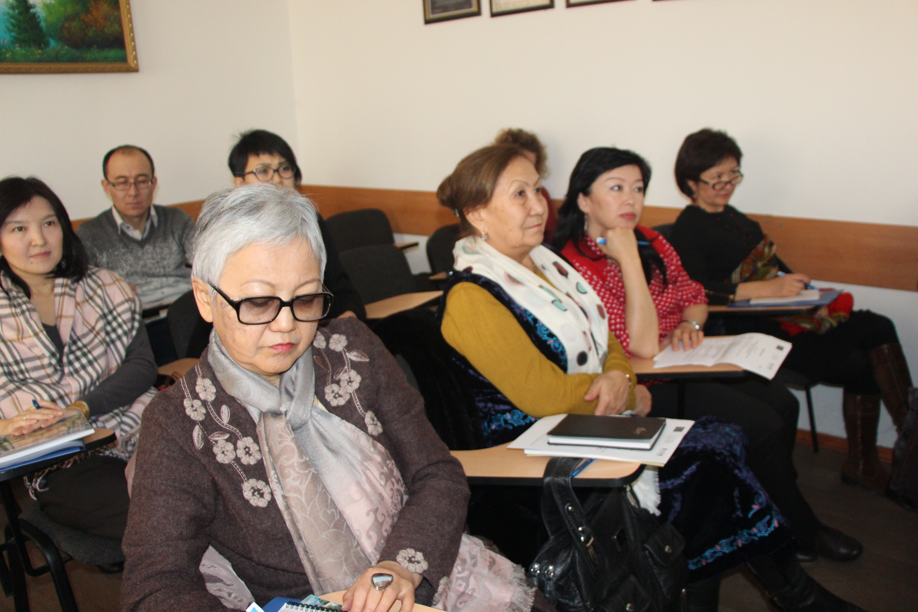

Workshop on the discussion of the content of education (presentation and discussion of the developments of the analytical expert group), 18.12.2015, Bishkek

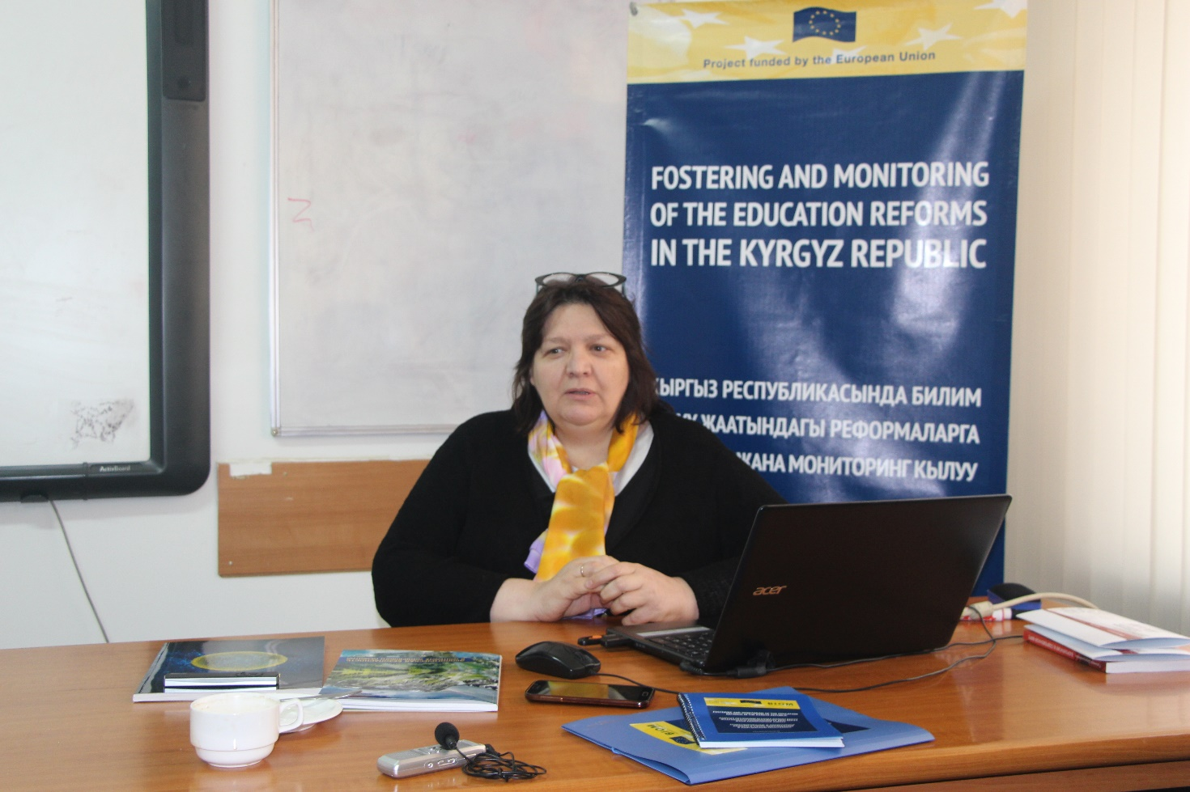

Speech of Dr. M. Glushkova (Director of the Center for Social Integration, Head of the Analytical Group on the content of the educational system)

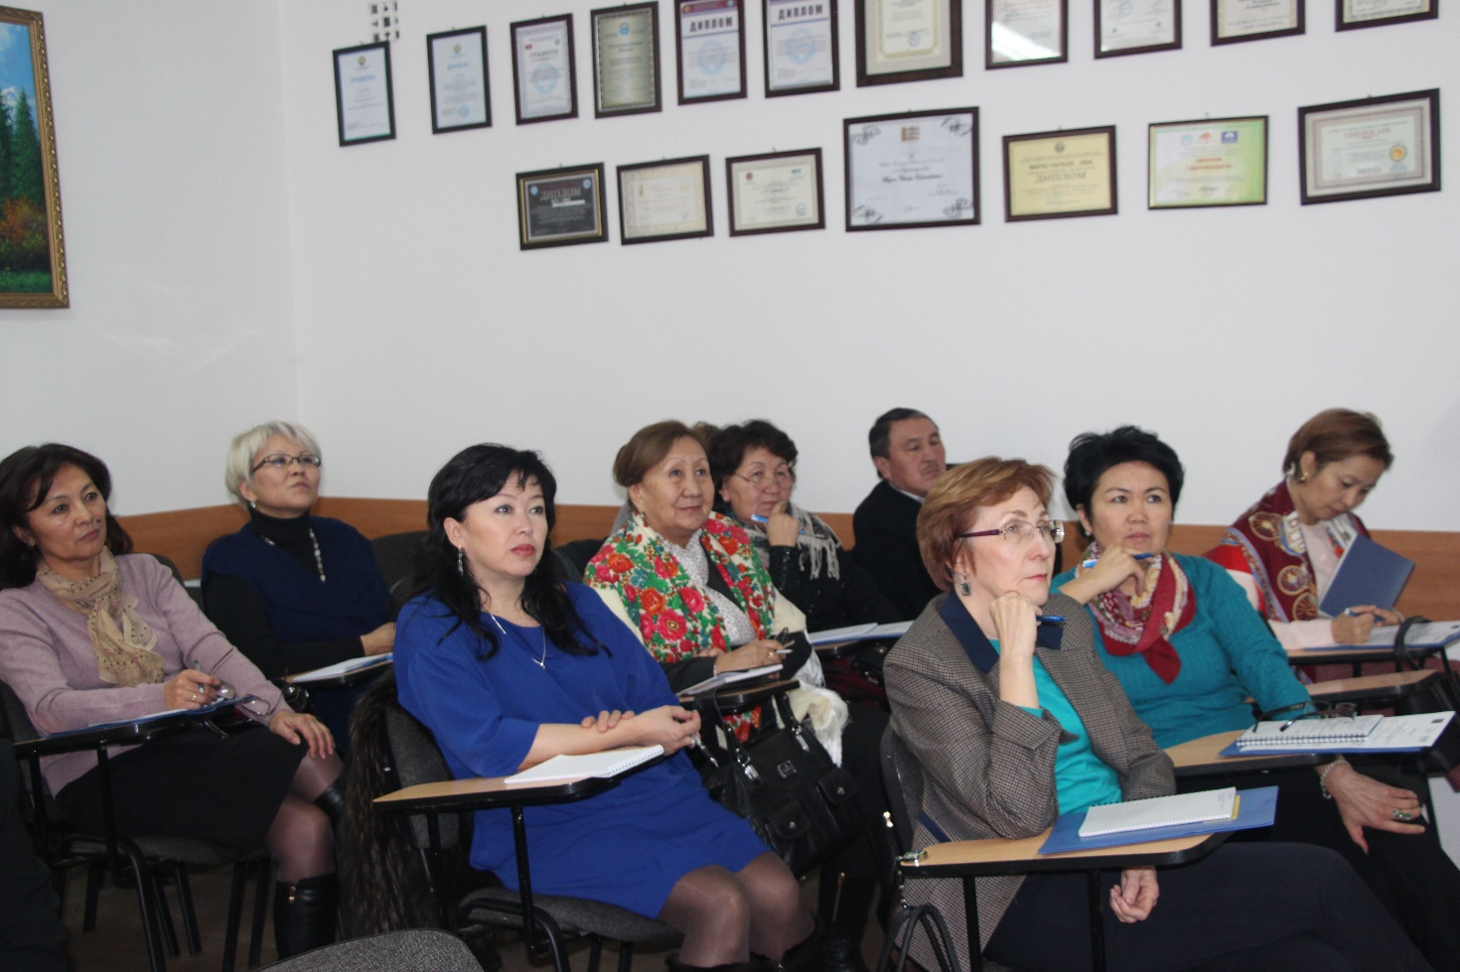

General meeting of experts with online participation of international experts to discuss reports of analytical groups, 08.01.2016, Bishkek

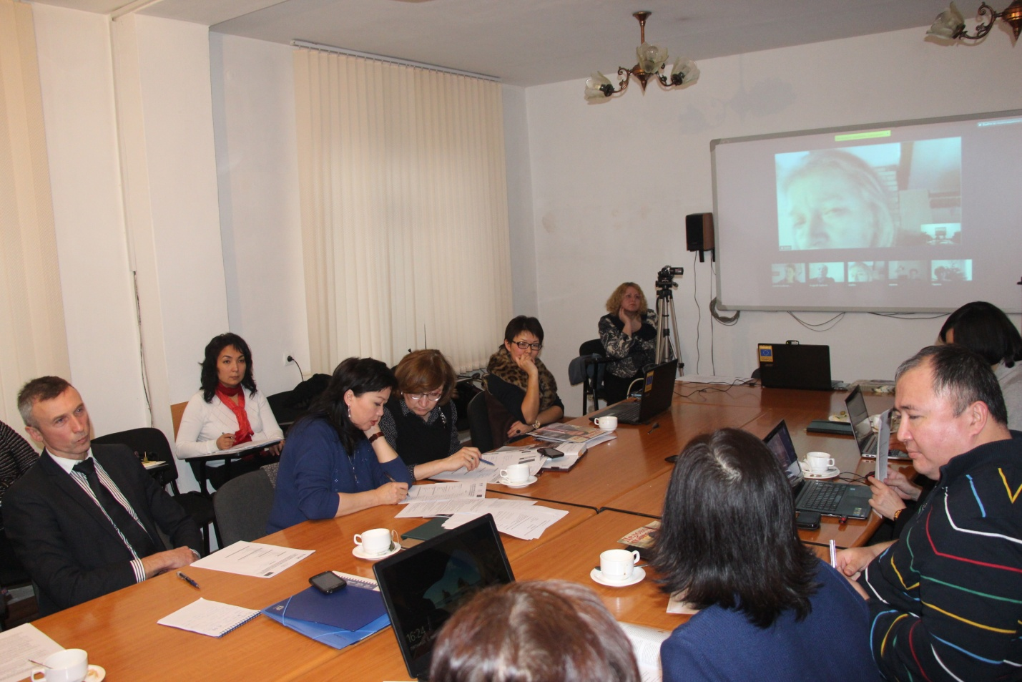

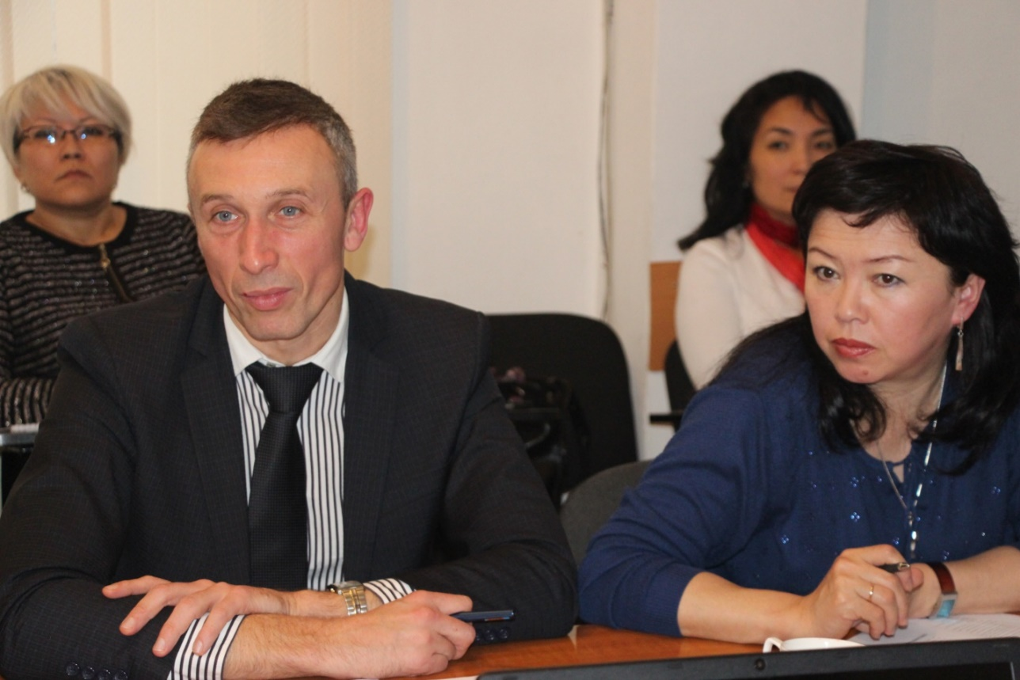

Seminar in the Ministry of Education and Science of the Kyrgyz Republic “Conceptual bases of education for sustainable development”, 08.02.2016, Bishkek

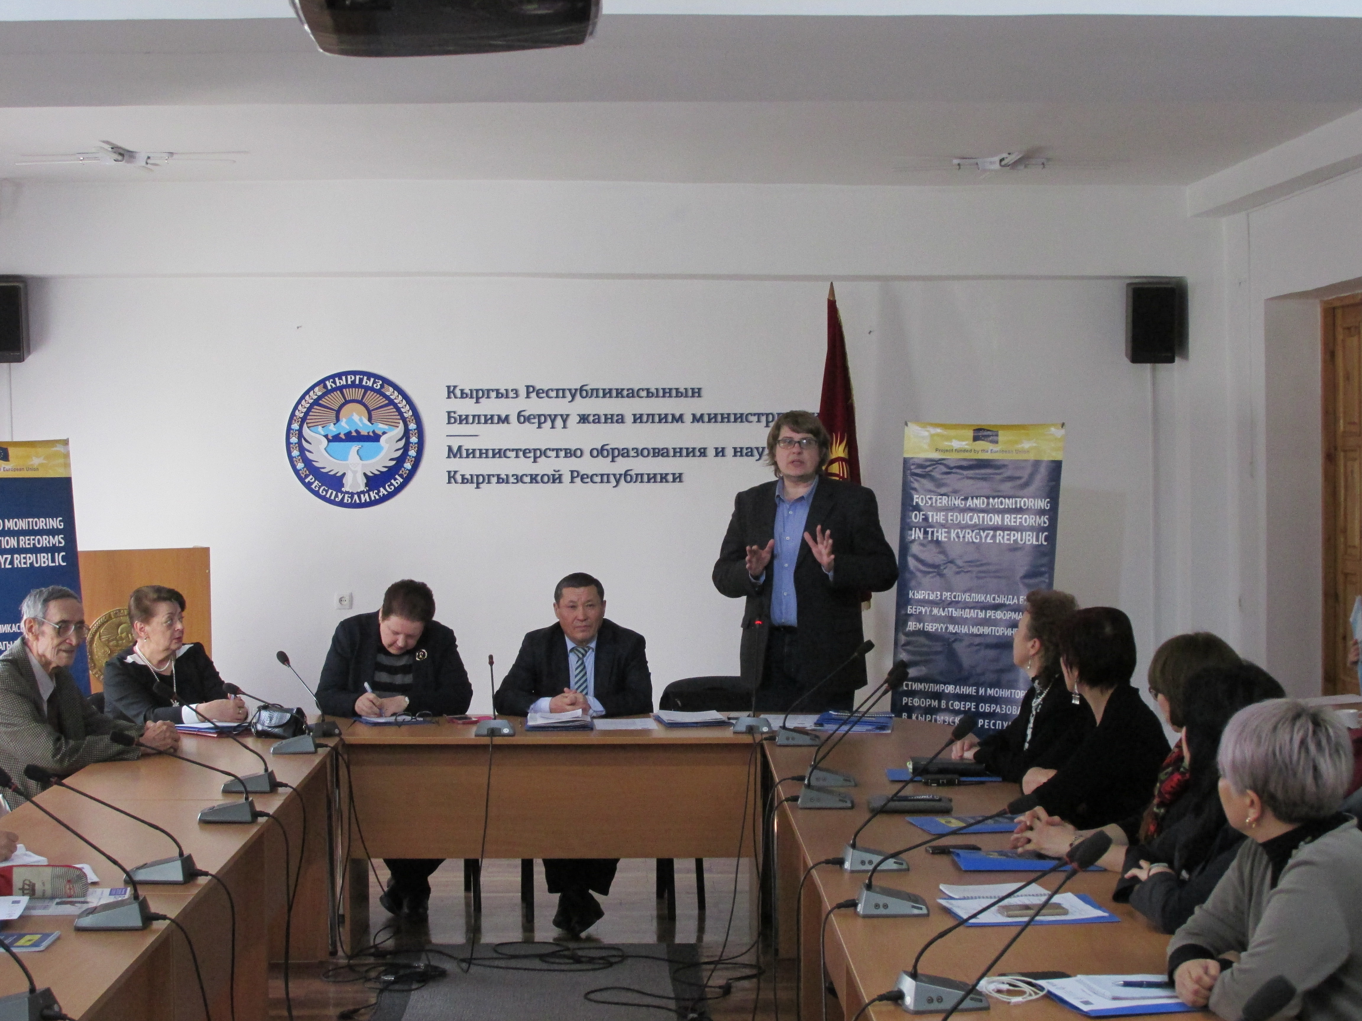

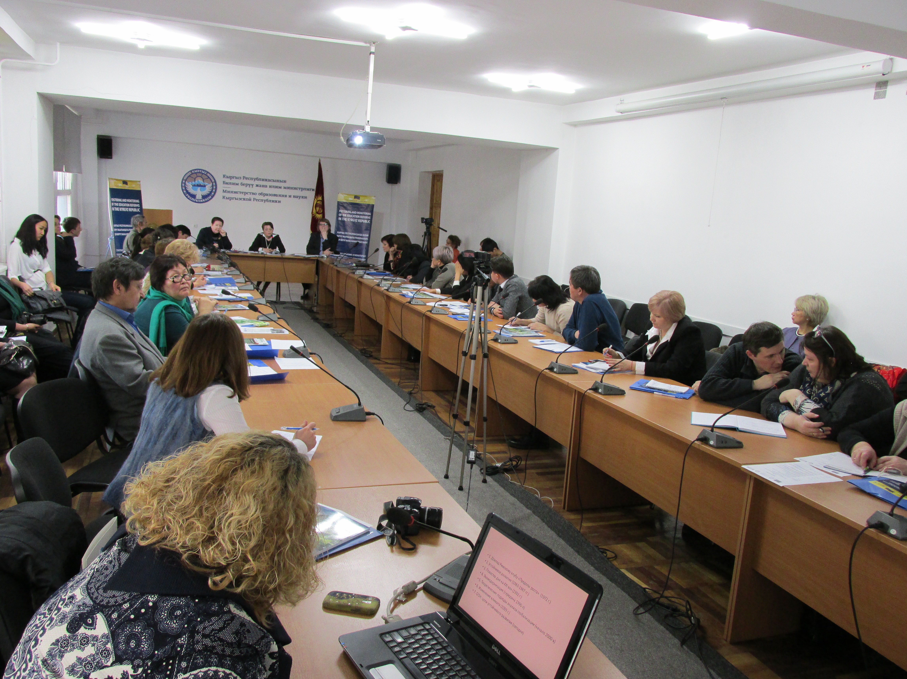

Seminar “Questions on the management of the education system in the Kyrgyz Republic: challenges and prospects”, 25.02.2016, Bishkek

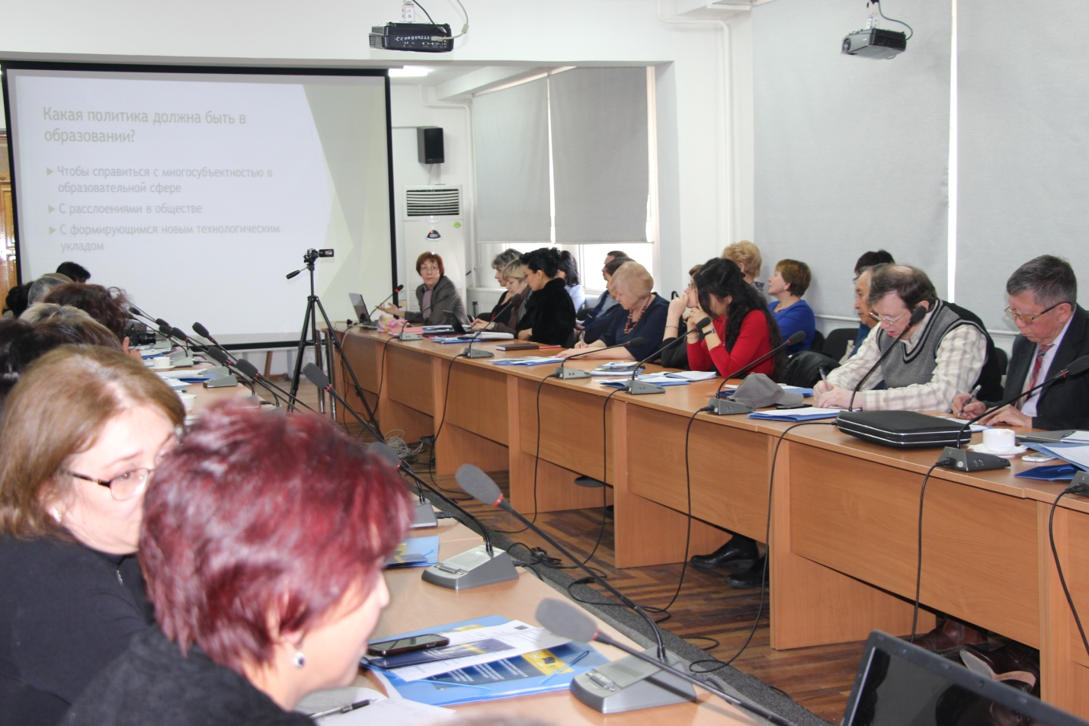

Speech of T. Tretyakova (Head of the National Monitoring and Evaluation Network)

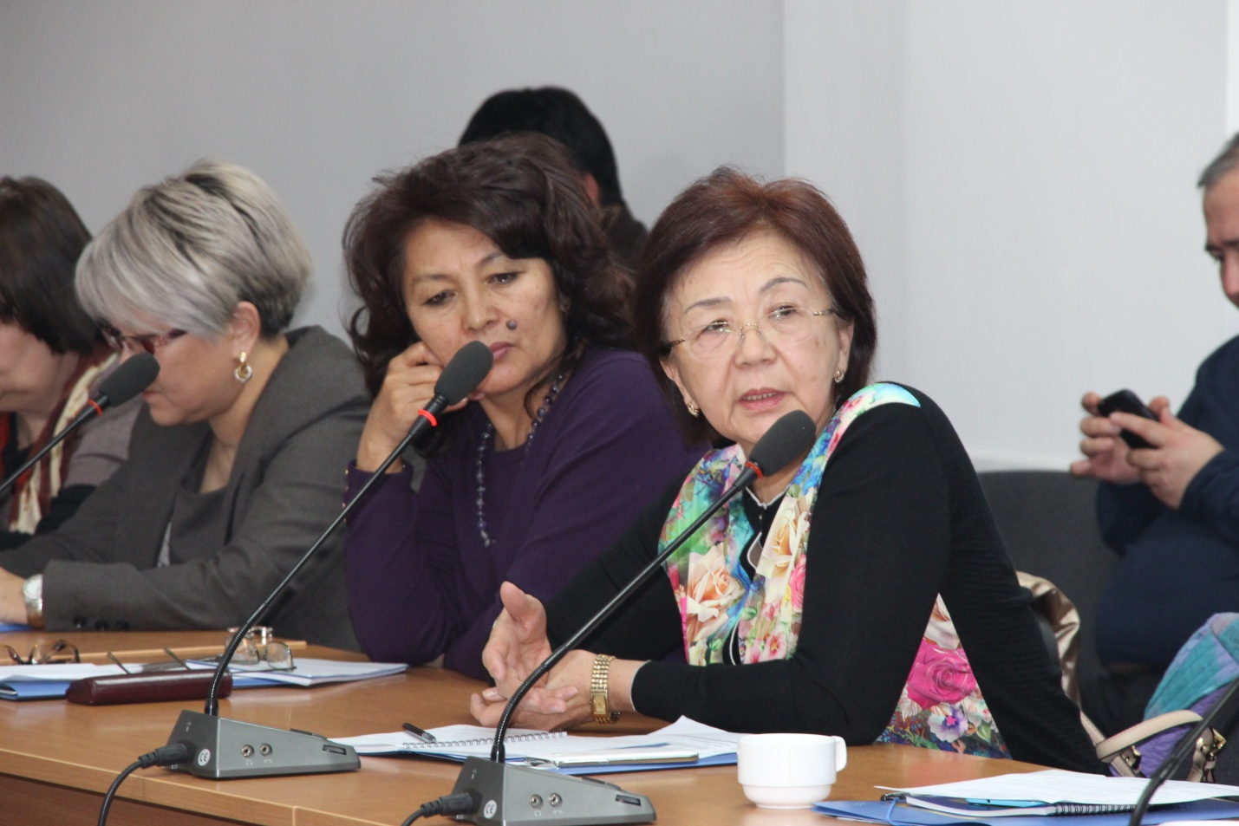

Speech by representatives of universities and schools

Working meeting of the project with members of the Public Council of the Ministry of Education and Science of the Kyrgyz Republic on joint action planning finalizing the strategic plan of EPAC, 08.02.2016, Bishkek
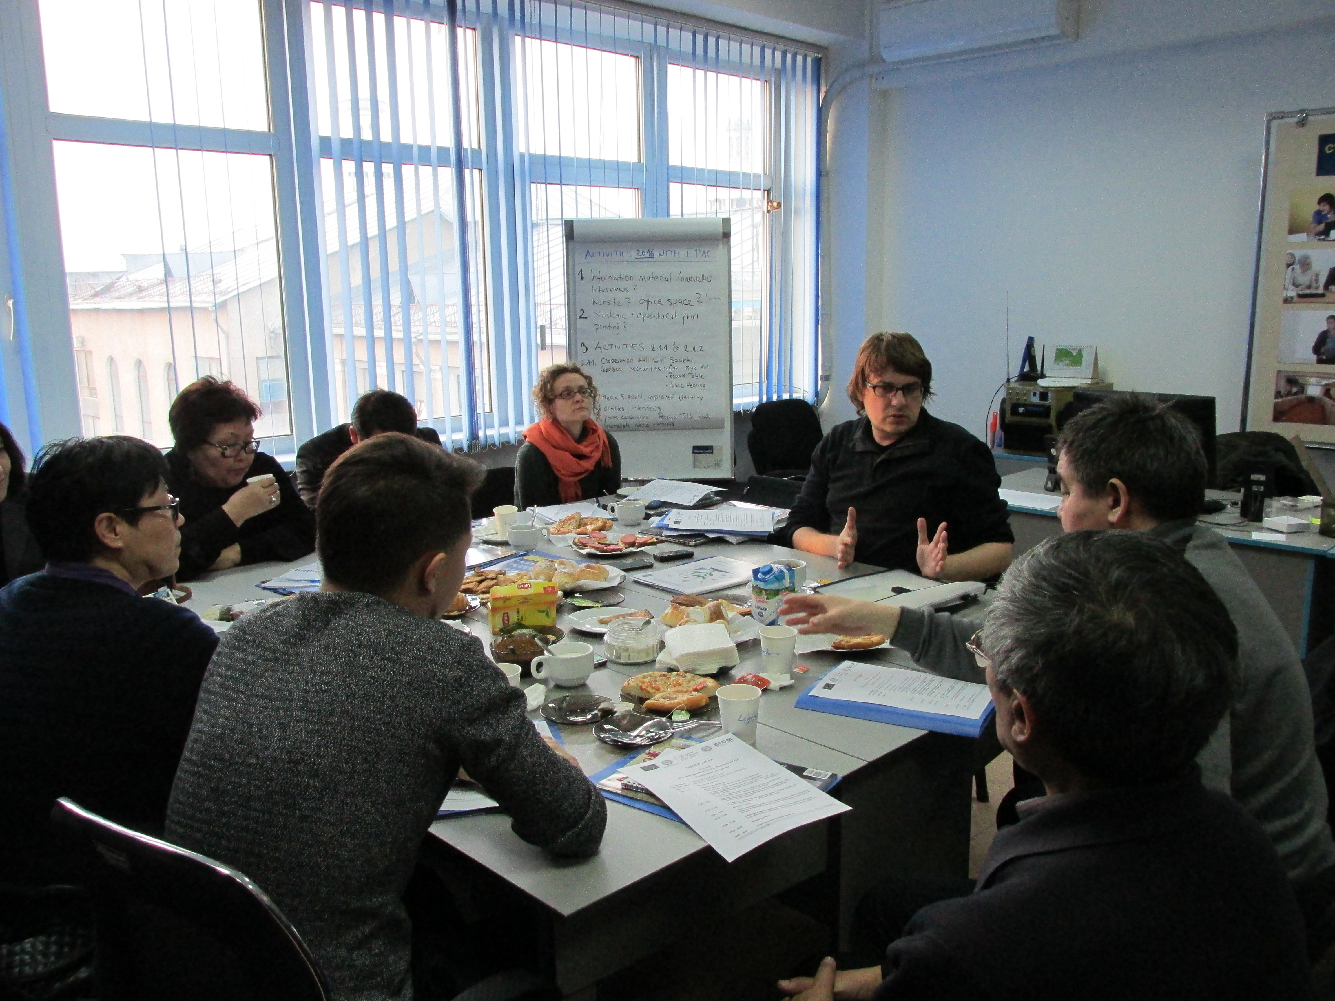

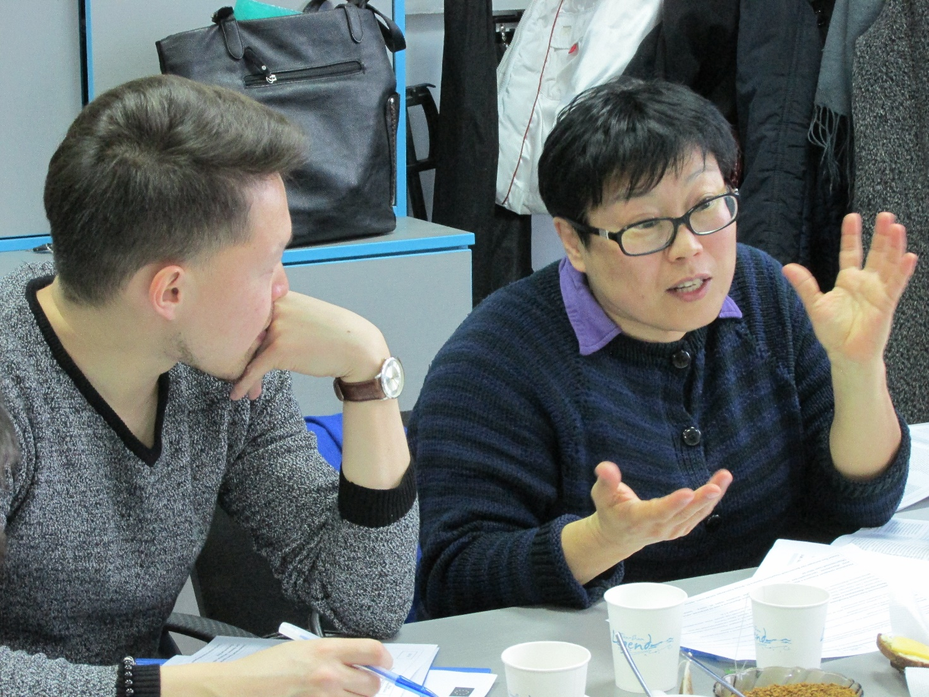

Support of Public Council of the Ministry of Education and Science of the Kyrgyz Republic – organization of a press conference, 29.02.2016, Bishkek

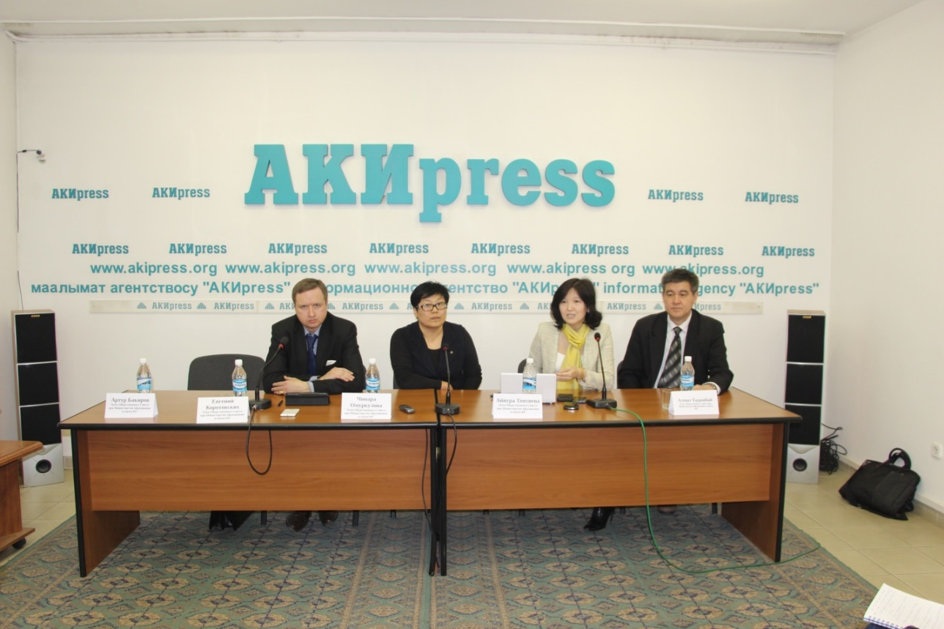

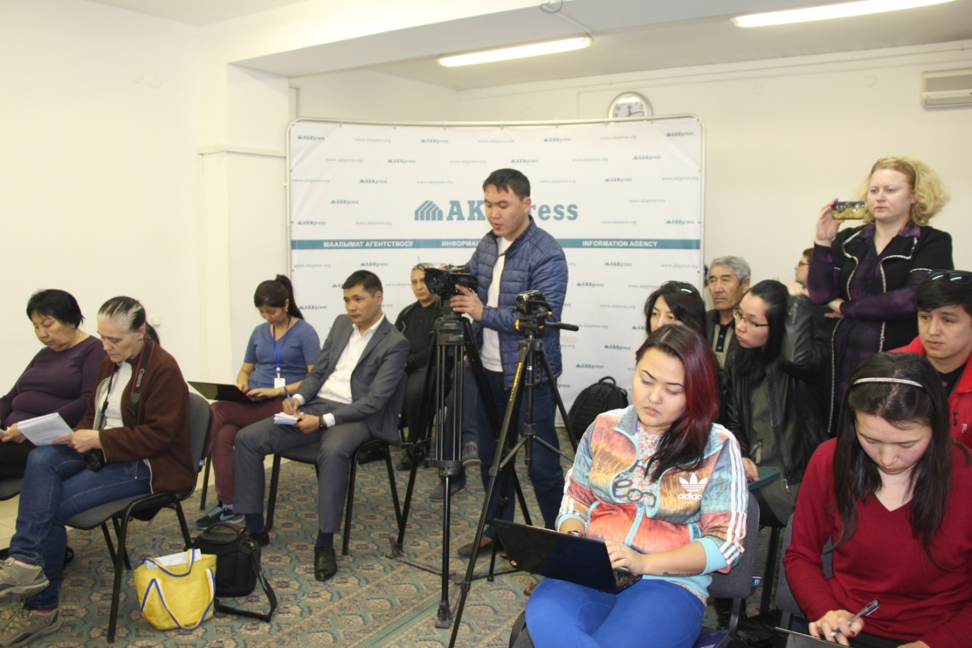

Public meeting of the Public Council of the Ministry of Education and Science, 25.02.2016, Bishkek

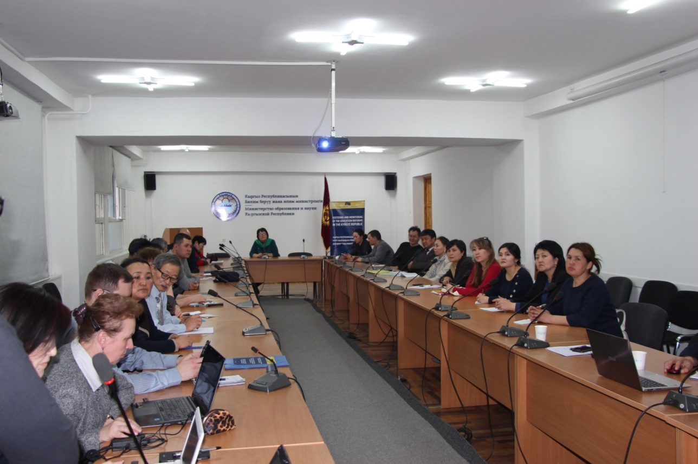

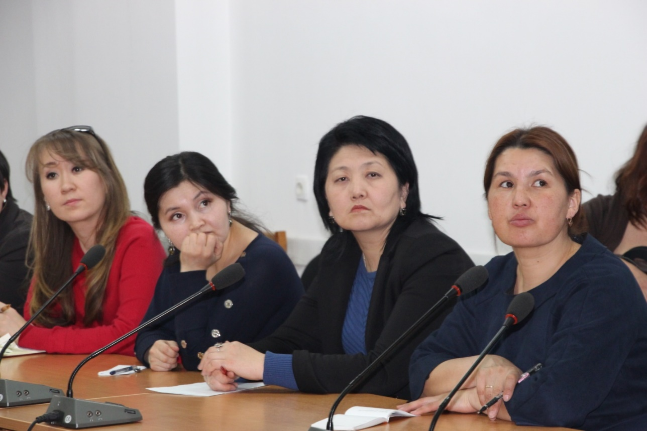

Working Group of Experts on Monitoring the Physical Environment in Schools, 22 March 2017, Bishkek

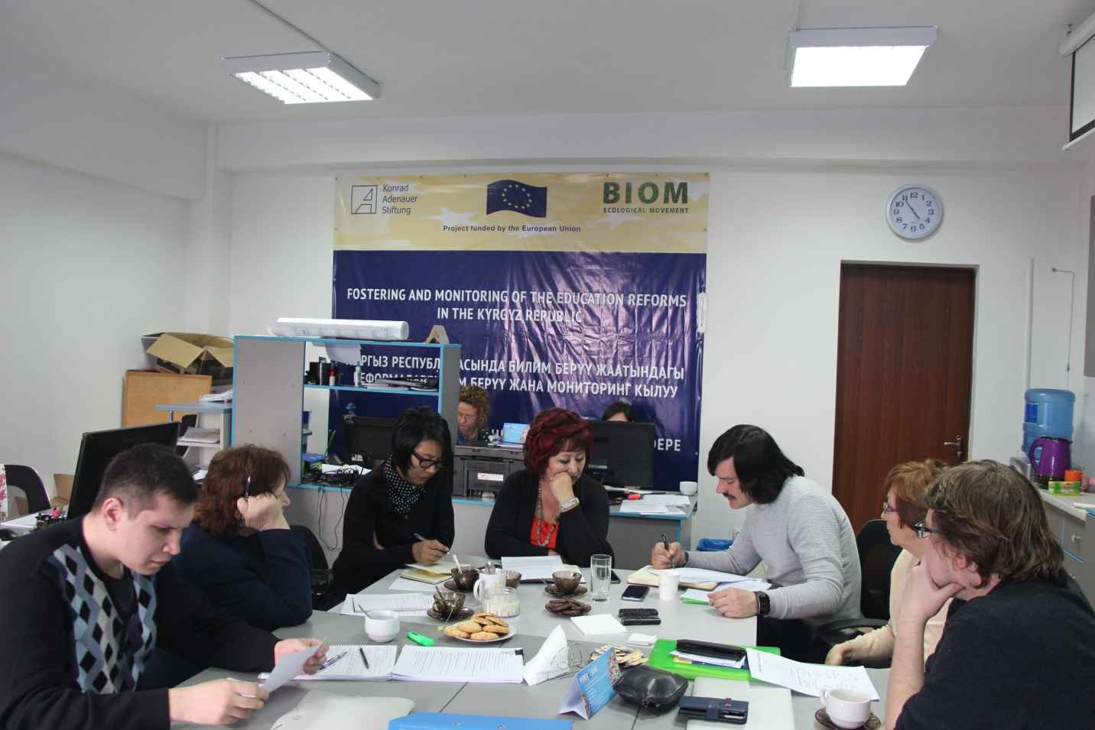

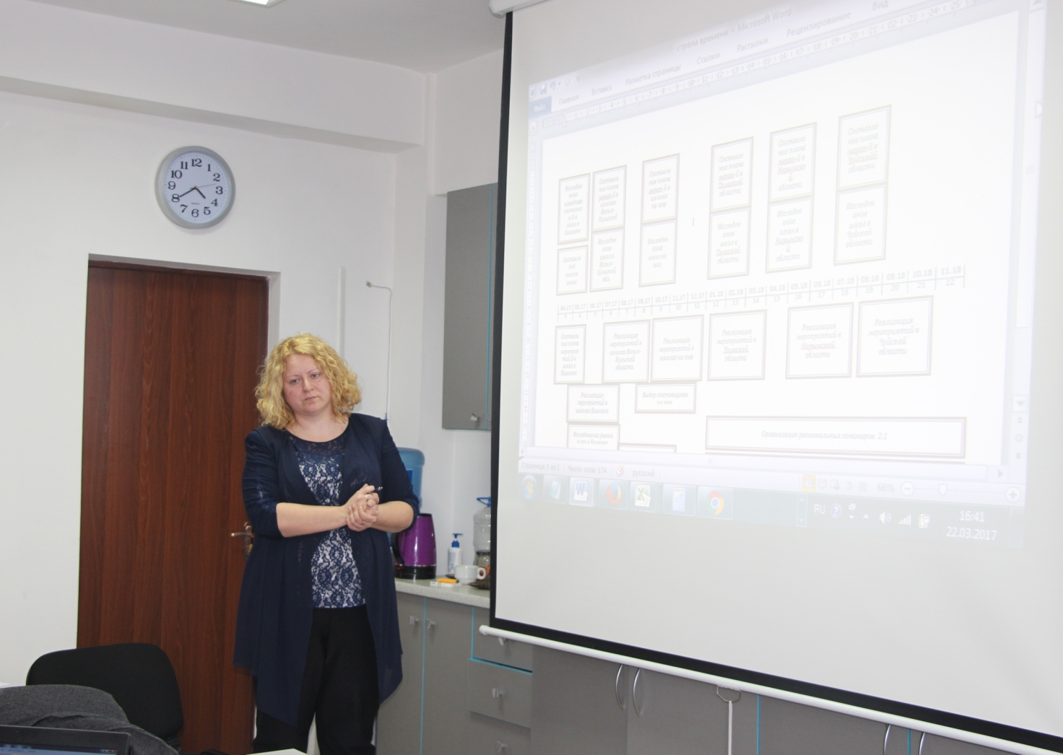

Speech of the Minister of Education and Science of the Kyrgyz Republic "Increasing the capacity of the Public Council of the Ministry of Education and Science of the Kyrgyz Republic in promoting education reforms" 31 March – 1 April 2017, Bishkek

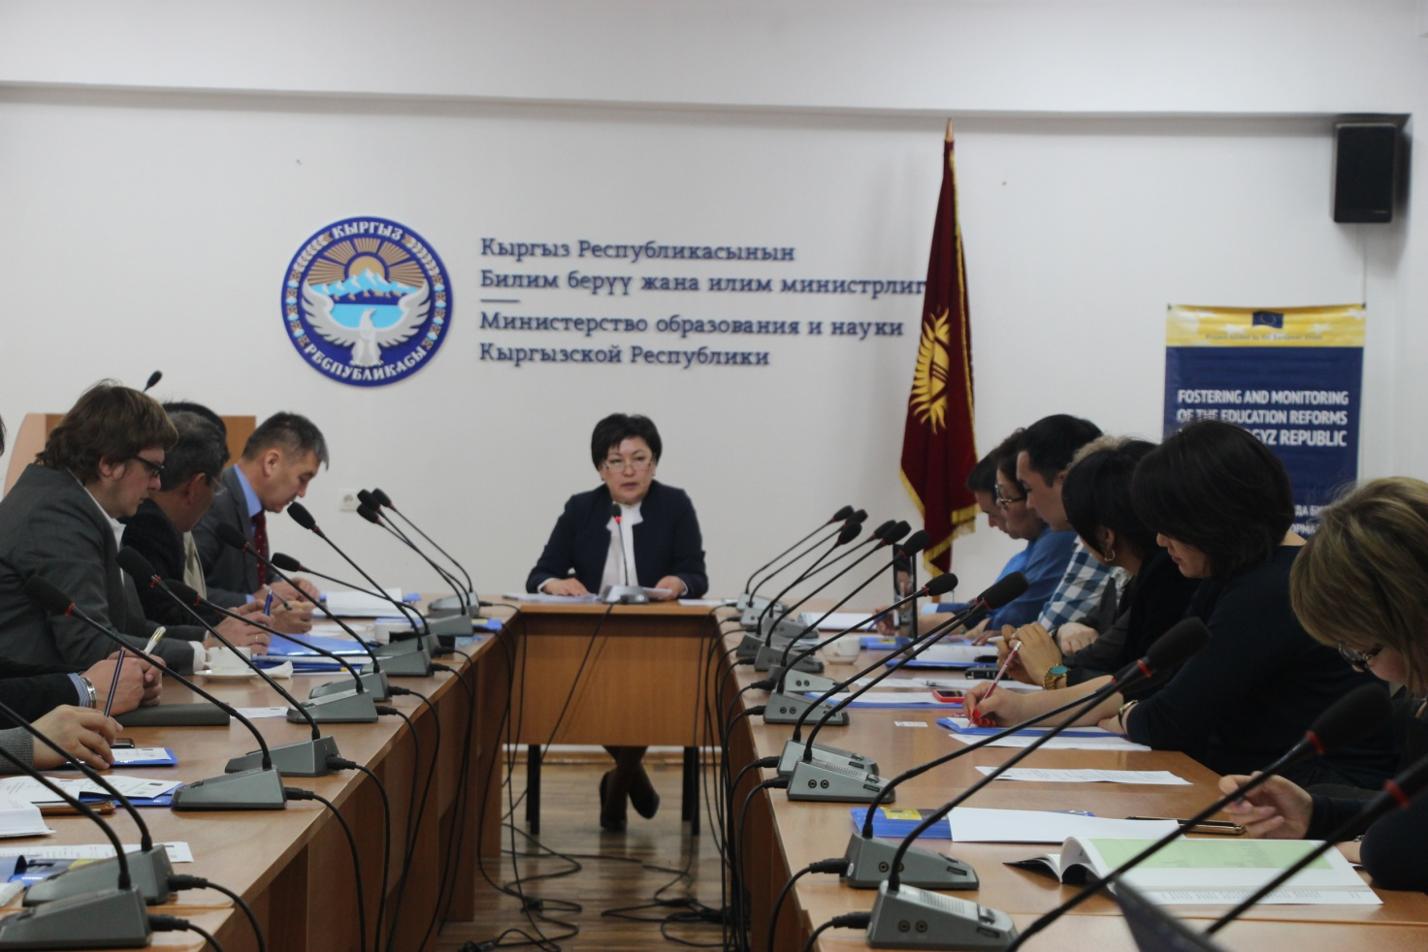

Speech of the Deputy Minister of Education and Science of the Kyrgyz Republic at the round table “Increasing the capacity of the Public Council of the Ministry of Education and Science of the Kyrgyz Republic”

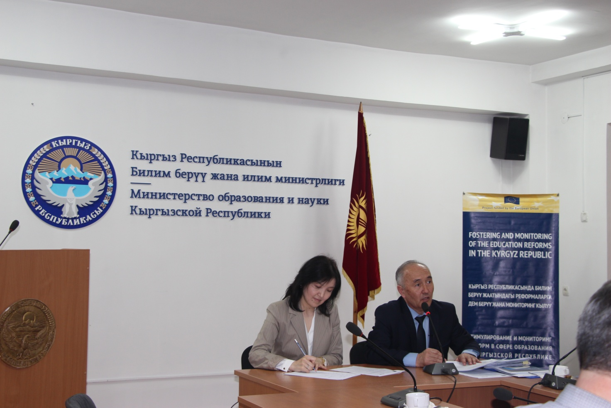

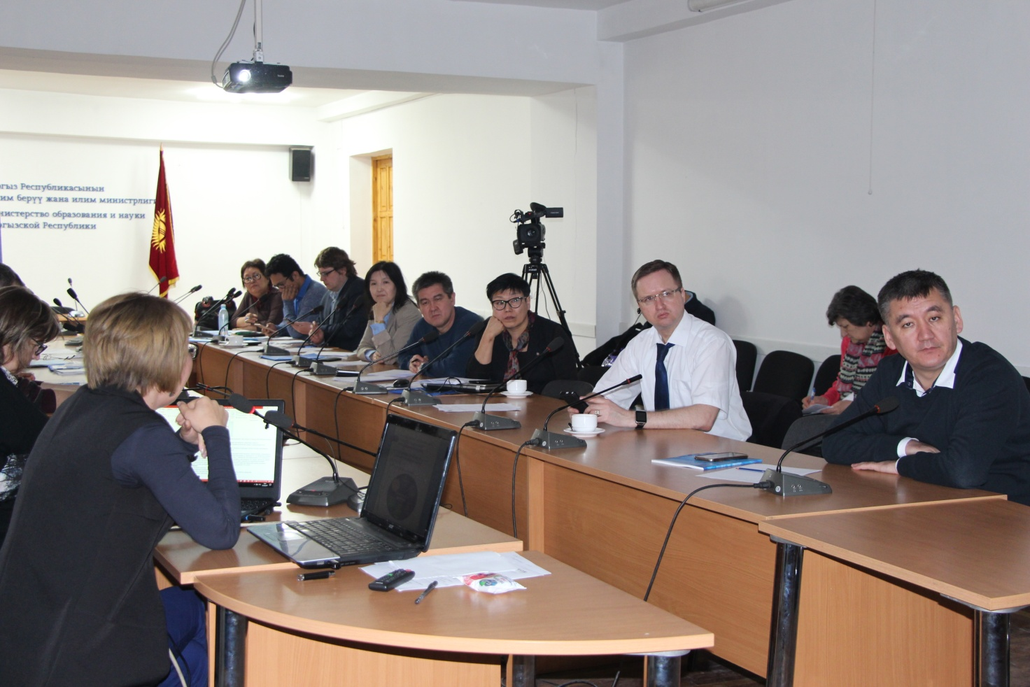

Round table "Monitoring of higher education reforms: E-learning in a modern university - challenges, prospects, technologies", 14 April 2017, Bishkek

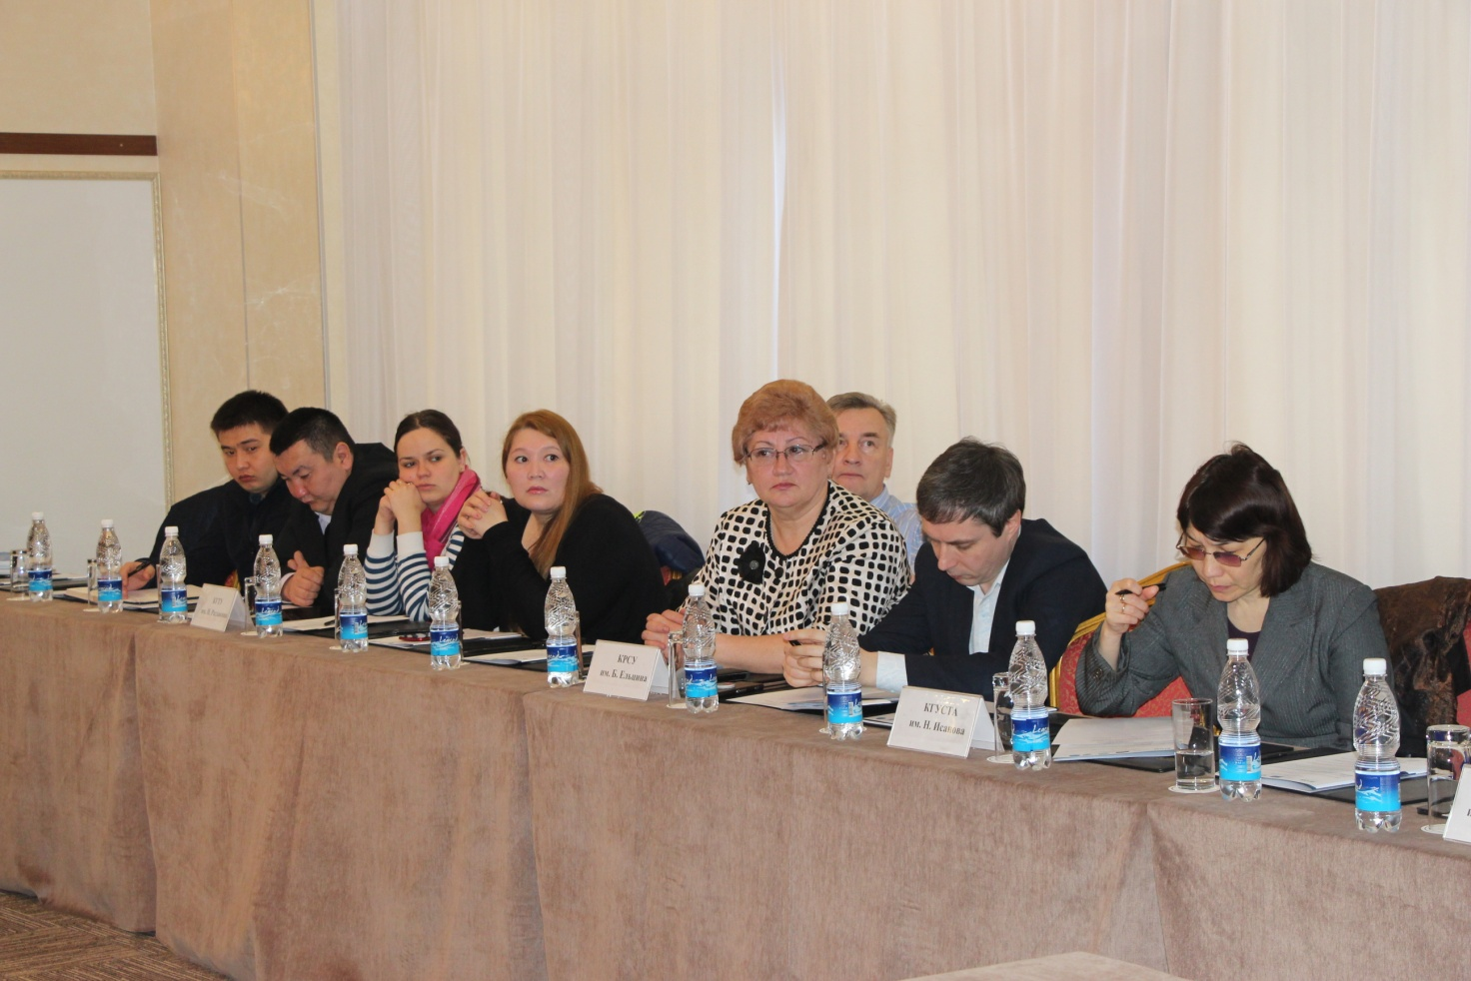

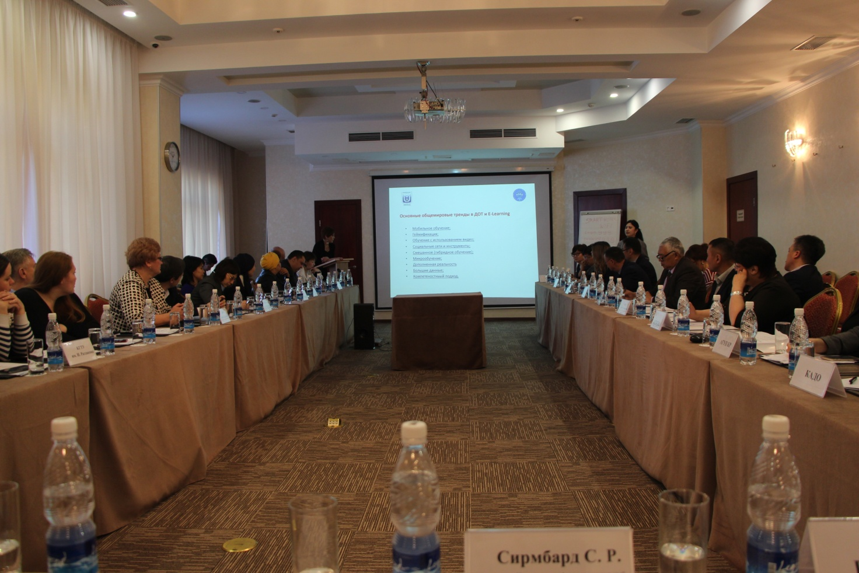

Monitoring visit to school №20 in the Osh city (determination of humidity, carbon dioxide and light levels), April 2017, Osh

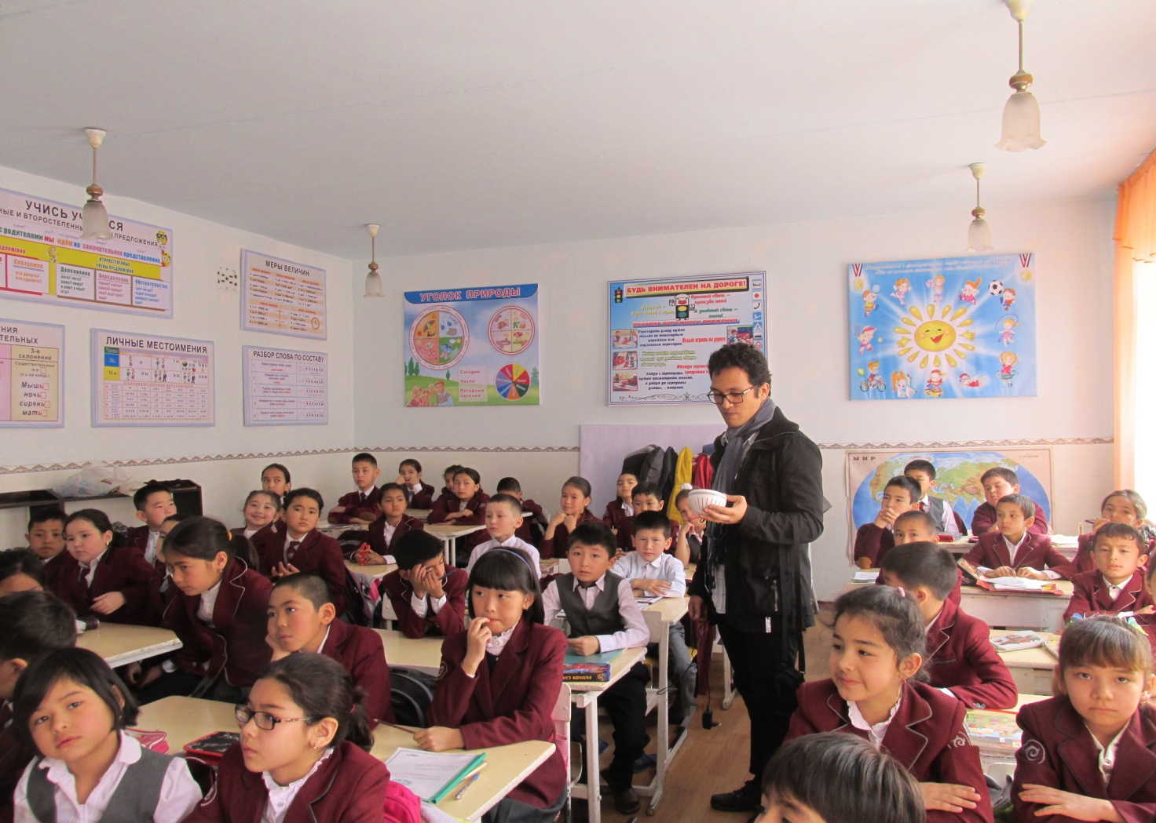

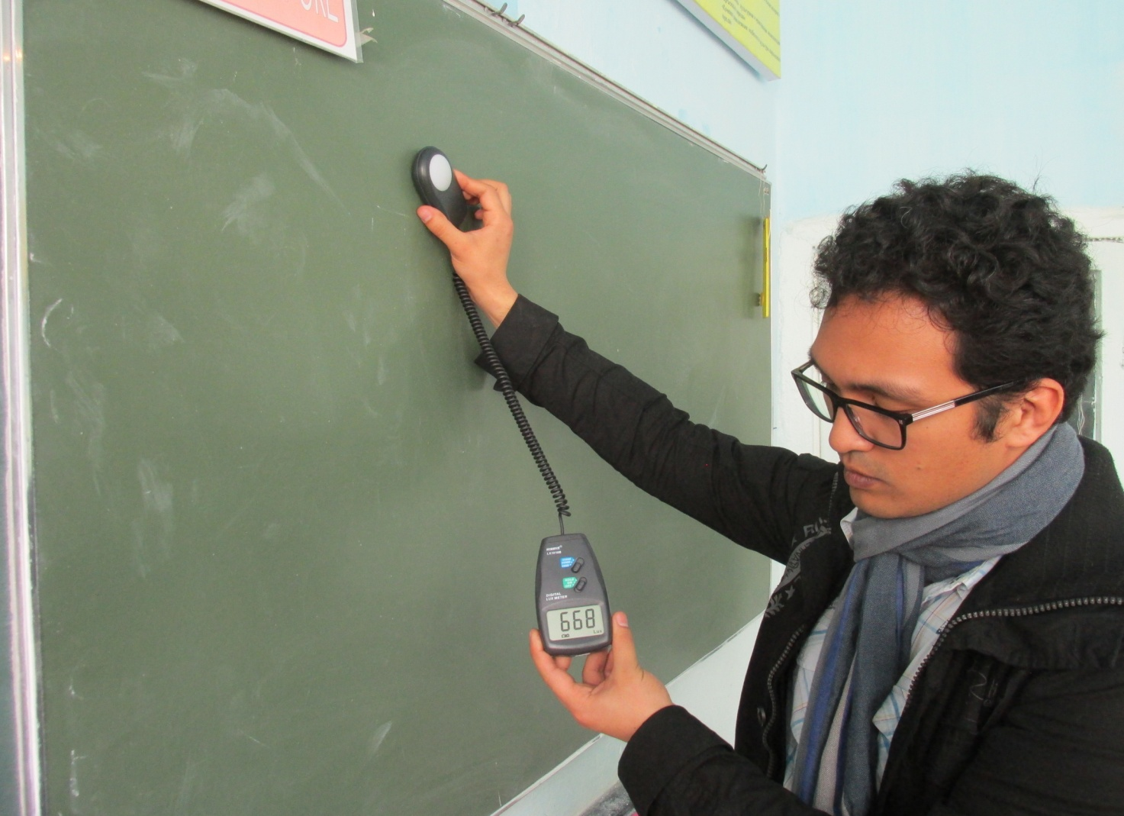

Monitoring visit to school №52 in the Osh city (determination of humidity, carbon dioxide and light levels), April 2017, Osh

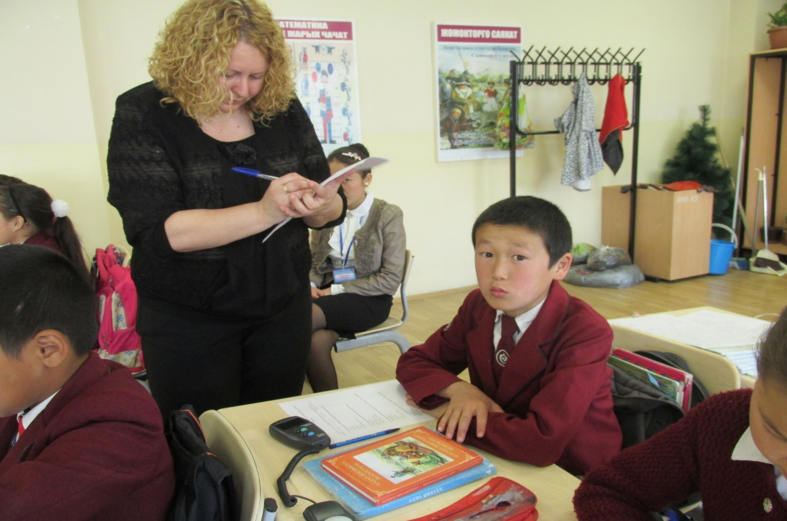

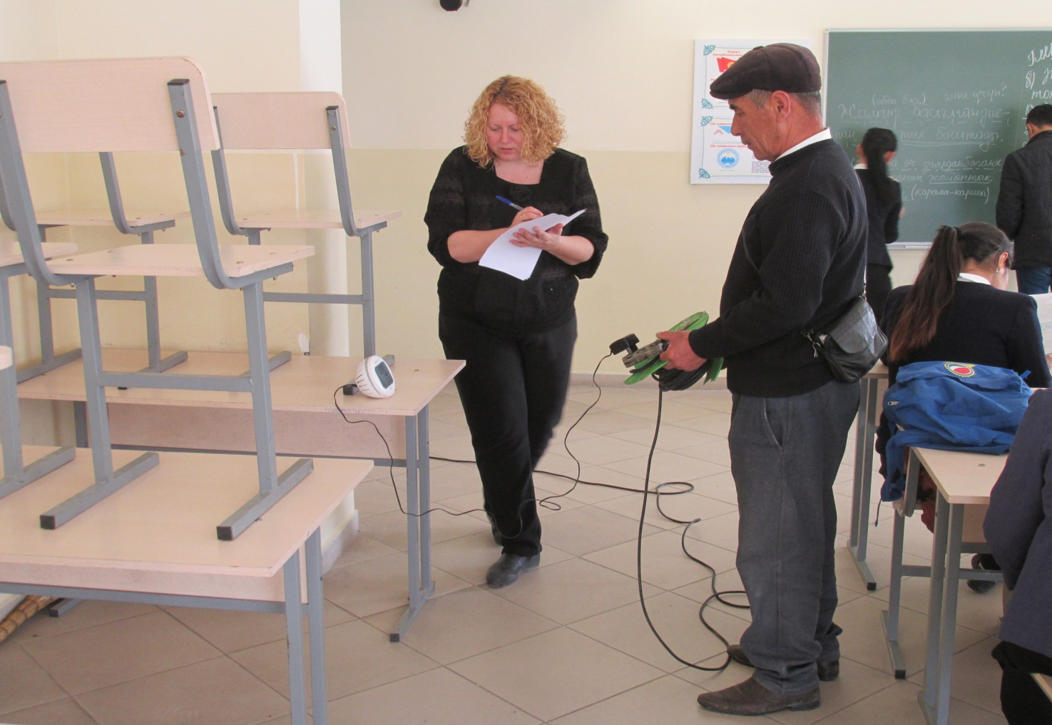

Monitoring visit to school №36 in the Osh city (questioning, measurement of physical environment parameters),
April 2017, Osh
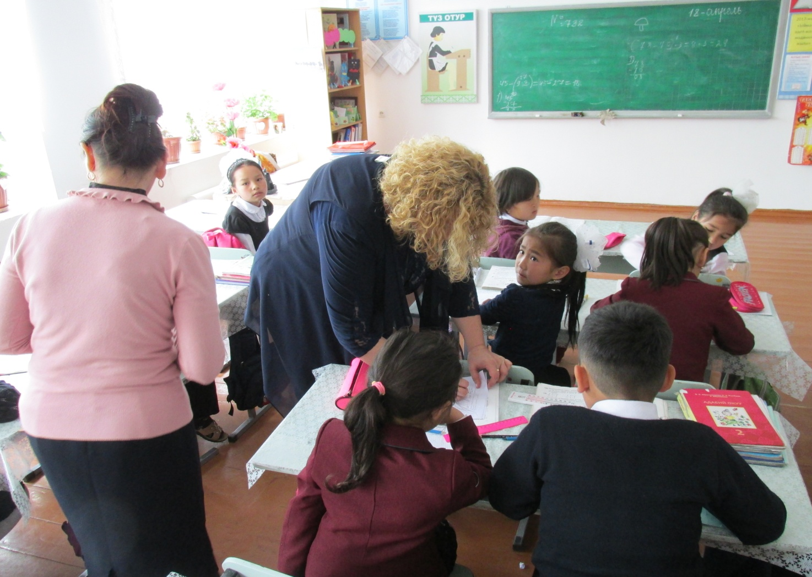

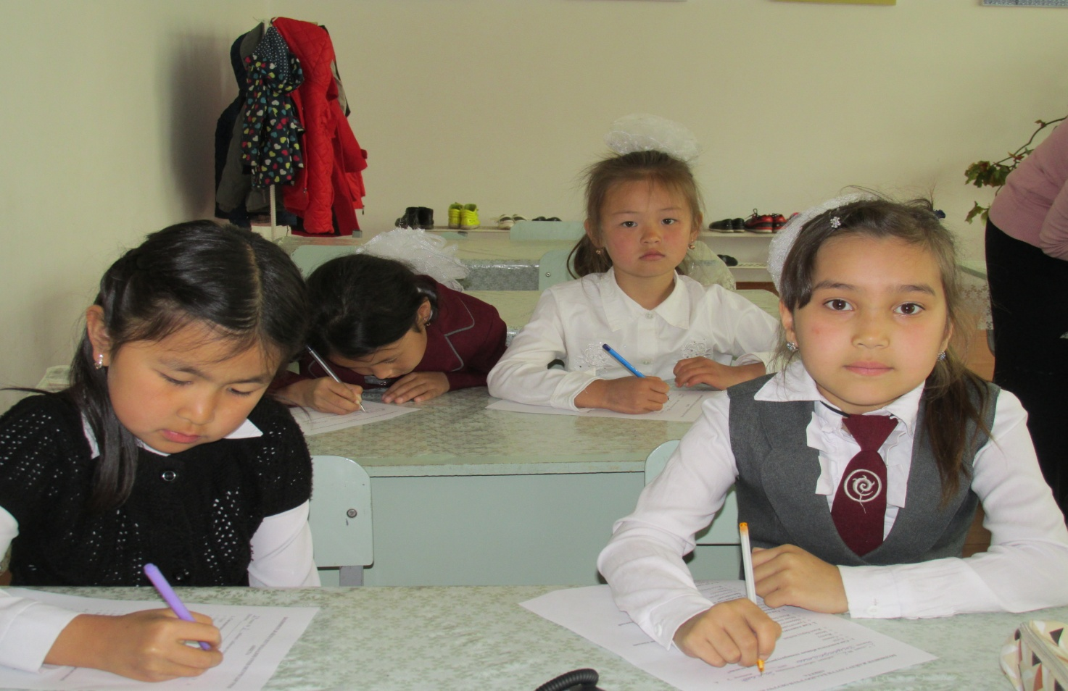

Round table "Development of the National model of monitoring and evaluation in the sphere of education", 14 June 2017, Bishkek

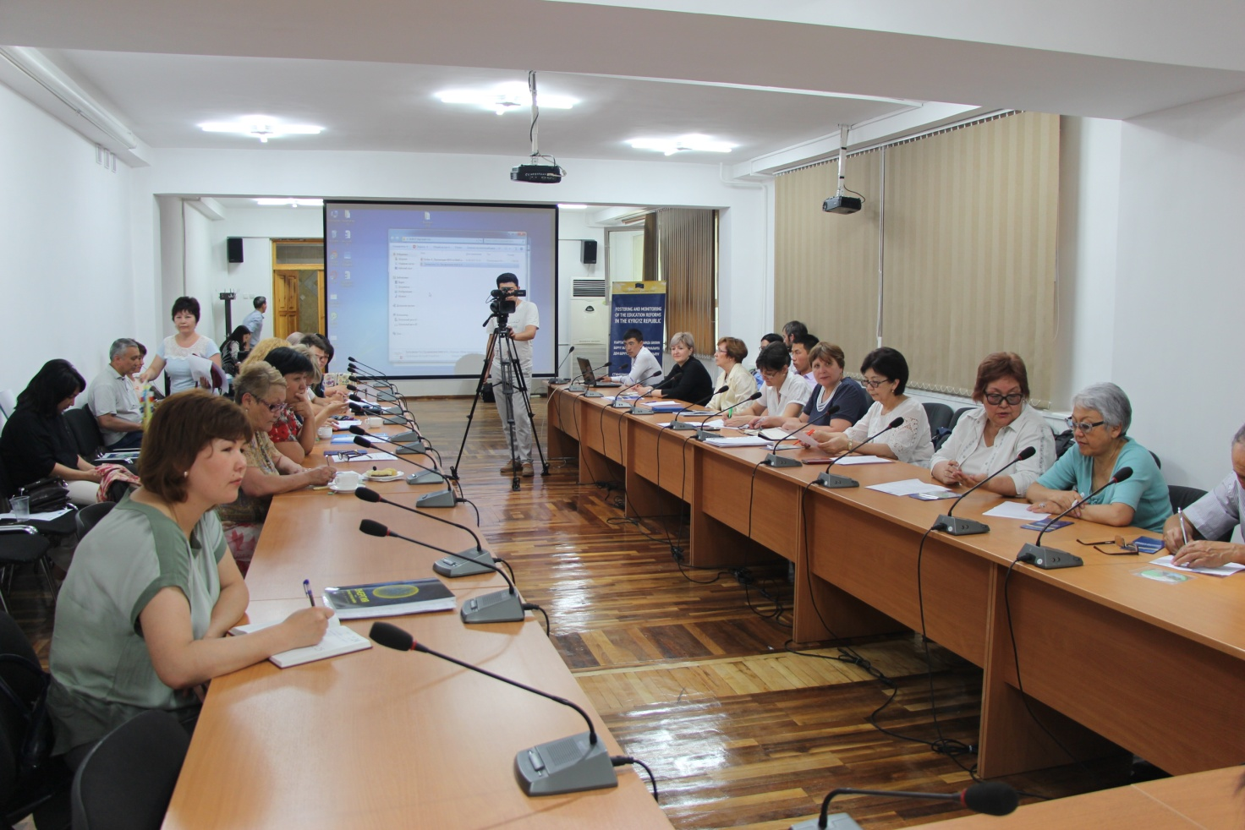

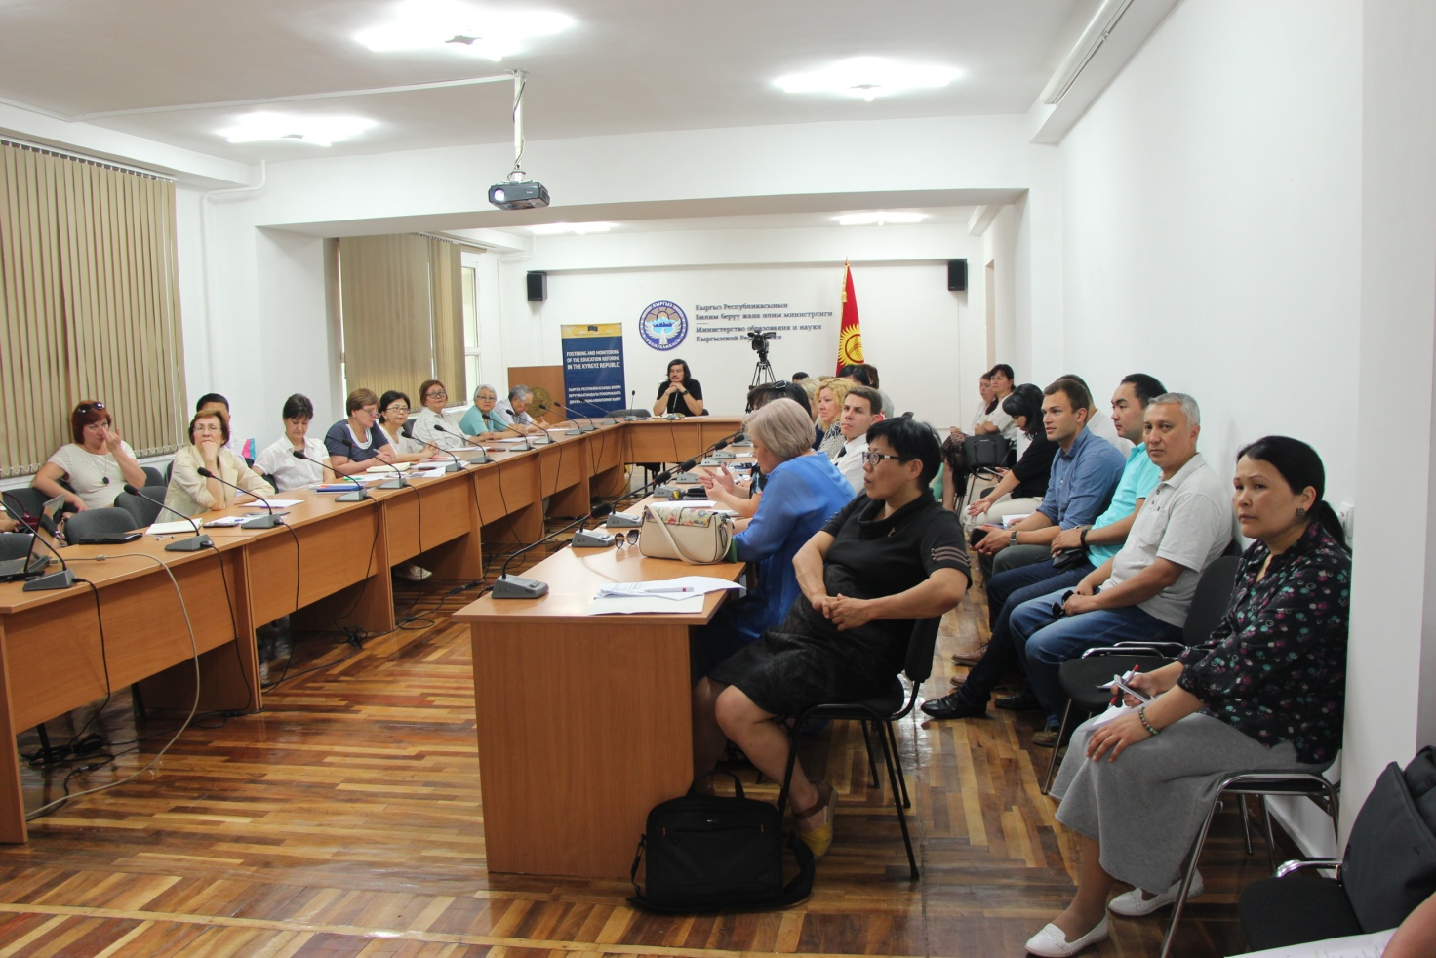

Workshop on training representatives of the Public Council of the Ministry of Education and Science of the Kyrgyz Republic on the basics of working with the web platform, 6 July 2017, Bishkek

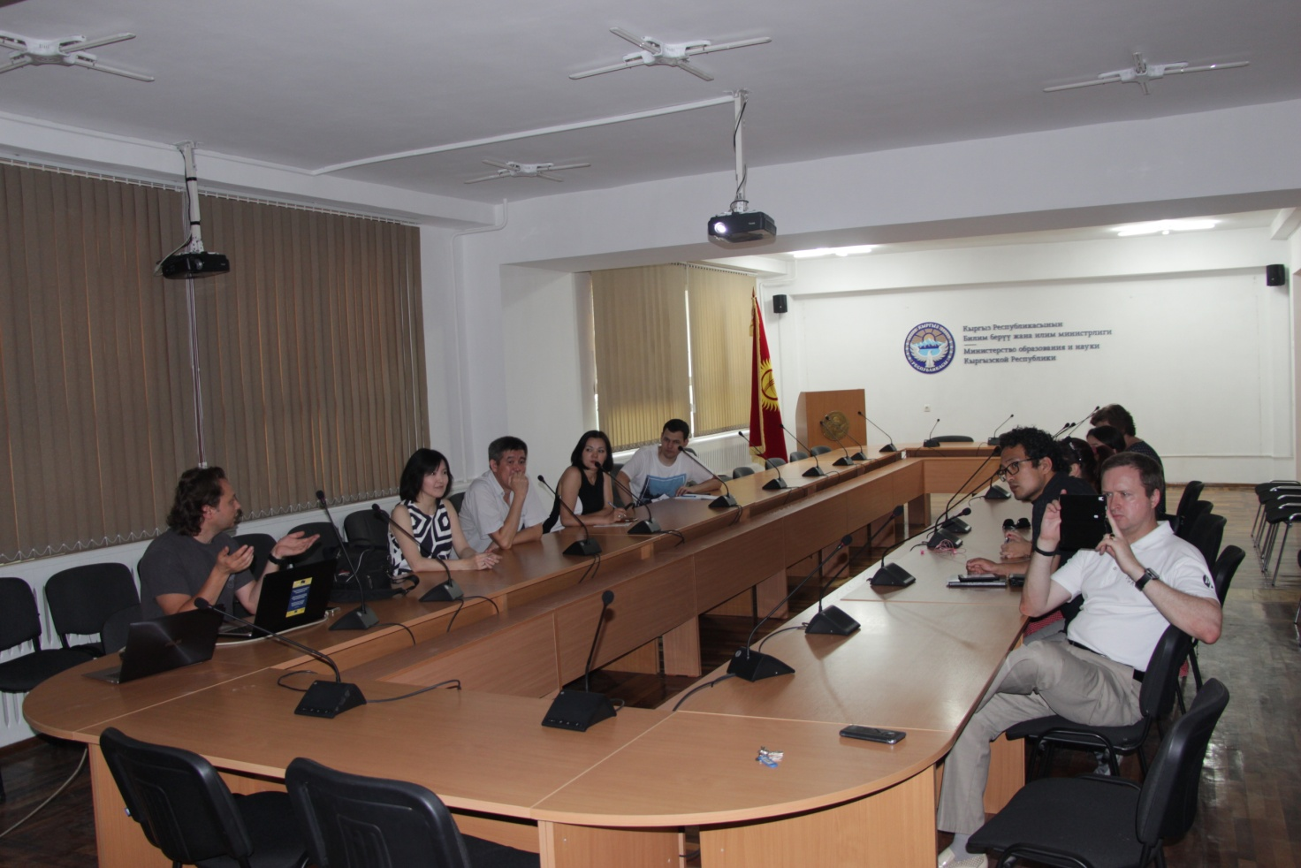

Ceremonial opening of the Cabinet of the Public
Council of the Ministry of Education and Science of the Kyrgyz Republic, 6 July 2017, Bishkek

